Climate Emergency Manchester
Report for Information and Discussion
Report to: | Necessary Extra Scrutiny and Capacity Building 27 May 2020
Subject: | Petition “Respond to Climate Change with more democracy and more money”
Report of: | Marc Hudson of Climate Emergency Manchester

Summary
Manchester City Council has an almost thirty year history of failure on climate policy. There is an obvious cycle of a) promise to do something because under public pressure b) not deliver because [insert excuse here] while claiming that HAVE delivered c) wait for those trying to get something to actually happen to give up and go away and then b) promise to do something because under public pressure.
While the City Council has more scrutiny committees than many other Local Authorities, the problem remains - for various reasons - that climate policy has never been regularly and forensically scrutinised. Officers and Executive Members have been able to play the usual games of burying mistakes, shifting baselines, “look a squirrel”ing and the like.
If we want to break the cycle, we need effective, regular scrutiny that cannot be ignored, fobbed off. Citizens have been trying to provide this, and should continue. However, citizenship scrutiny on its own is simply not enough. Manchester City Council urgently needs a scrutiny committee dedicated to climate policy. This was true before coronavirus, and will be even more true as the desire to ‘bounce back’ (rather than bounce forward makes it easier to ‘cut the green crap’.
Climate Emergency Manchester as created a petition to this effect. We need help with it.
Recommendations
It is recommended that the Committee:
- Discuss ways that the online petition can be jump-started
- Try to think up ways that collecting on paper might be doable safely during and after a lockdown, and then get proper scientific advice (which may well be “DON’T EVEN...”).
Wards Affected: All

Contact Individuals:
Name: Marc Hudson
Position: Core Group member of Climate Emergency Manchester
Email: marc@climateemergencymanchester.net

Background documents (available for public inspection):
The following documents disclose important facts on which the report is based and have been relied upon in preparing the report. Copies of the background documents are available online.

Council’s petition scheme
https://secure.manchester.gov.uk/info/10095/petitions/4759/create_an_e-petition/2
https://secure.manchester.gov.uk/downloads/download/3980/petitions_scheme

Our 2019 campaign
https://climateemergencymanchester.net/2019/04/04/why-a-climate-emergency-petition/
Our 2020 page(s)
https://climateemergencymanchester.net/petition-2/
1.0 Introduction
1.1. The following report gives a very brief background to the rationale for the creation of the 2020 petition, the initial progress it made, and some suggestions of how further progress might be made. Ultimately, we will only get a seventh scrutiny committee if there is a broad-based campaign of people calling for it.

2.0 Background
2.1 | Manchester City Council has been making fine statements about the importance of sustainability and tackling ‘global warming’ (now climate change) since the early 1990s. However, its “inward investment at all costs” wing has won all the battles over clean air, the expansion of Manchester Airport etc etc
2.2 | The most recent wave of promise-making began in 2016, and kicked into high gear in late 2019. However, scrutiny arrangements have remained weak, with the Executive often unable to understand or respect the role that scrutiny plays in a Westminster system. Given the overwhelming dominance of one party in Manchester, we cannot expect change to come from within the Council, without significant, prolonged, diverse external pressure (and even then, well, you wouldn’t bet on it).
 | 2.2.1 Manchester CIty Council, as with all other Local Authorities, now has a petition scheme. If one per cent of the people who live, work or study within the physical boundaries of the Authority sign a valid petition, giving their signature and address, then a full Council meeting will debate the petition’s content (and may then accept or reject the petition). This is distinct from other petition sites, which - while easier to get signatures on - have precisely zero legal standing. For petitions in Manchester, this would come to 4000 signatures.
2.3 | In March 2019, two people (Marc Hudson and Calum McFarlane), who would become core group members of Climate Emergency Manchester established a petition on the City Council’s website calling for the Council to declare a climate emergency, set a target date of zero carbon for 2030 and include some proportion of the Airport’s aviation emissions in its carbon budget (Manchester City Council owns 35.5% of Manchester Airport Group, and - until the virus began to stalk the land - got a handsome annual dividend.  CEM did not anticipate that the City Council - under pressure from a variety of factors (most other Core Cities declaring a climate Emergency, the School Strikes, etc) would actually do so. In the end, the petition gained just over 1000 valid signatures (and far far too many invalid ones). It was discussed at a Neighbourhoods and Environment Scrutiny committee a million years ago, in January 2020.
2.4 | In early February 2020, after extensive discussion in the core group of Climate Emergency Manchester about the pros and cons of another petition campaign, we submitted a petition to the City Council under the heading  “ Respond to climate change with more democracy and more money”  “We the undersigned petition the Council to Establish a permanent “Climate and Environment Scrutiny Committee”, of equal standing to the existing 6 scrutiny committees Make strenuous efforts to secure additional funding for climate action, including the use of some of its strategic reserves.”
2.5 | This was approved quickly by the City Solicitor, and the officers who administer the petition scheme arranged for it to go live on the 10th February at the following address.  https://democracy.manchester.gov.uk/mgEPetitionDisplay.aspx?Id=36

3.0 What is going well
3.1 | The petition began well - with 60 people managing to get through the cumbersome signing procedure on the first day (February 10), and a steady increase most days afterwards.  Excellent graphics were made for us, pro bono, (thanks Laura!) and this pushed up online signatures.  Currently the number is at 254 (there has been minimal publicity for the petition, and minimal signing, since early/mid March)
3.2 | CEM created clear guidance on how to collect signatures so that they are valid.  https://climateemergencymanchester.net/wp-content/uploads/2020/02/cem-signature-advice-2020-02-09-1.pdf  CEM and its allies also collected signatures at events, including various Climate Strikes, lectures, meetings etc. “Milestone” interviews were being conducted, appearing on our website when the petition passed 100, 200 etc.  We were beginning to get invitations to engage in schools. Two businesses - Patagonia and The Sandbar, agreed to be collection points for people to pick up blank petition sheets (which can also be downloaded from the CEM website)  https://climateemergencymanchester.net/wp-content/uploads/2020/02/Petition-sheet-2020-02-14.pdf  and drop-off points for completed sheets.
3.3 | Plans were afoot for monthly online and on paper ‘blitzes’, with a target of having collected the required 4000 valid signatures by the end of May.
3.4 | And then came the virus.

4. 0 What is going badly
4.1 | CEM was doing well, but not perfectly.  - We did not have videos explaining the petition  - We did not have people who had signed the petition making videos  - The sending of direct messages to Twitter followers yielded relatively modest results.  - There was no printed flyer briefly explaining the petition and encouraging those who signed on paper to share it more broadly
4.2 | Signing the petition online is actually far more difficult than one of the more “popular”/famous (but again, not legally binding!) sites. CEM has had several exasperated emails from citizens unable to sign the petition, despite multiple efforts.  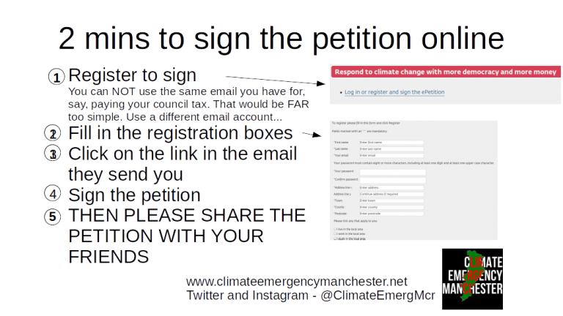
4.3 | There have been several discussions within CEM about when might be the right time to re-launch the Petition. The news cycle is - understandably - full of coronavirus. However, once the lockdown ends, it will be full of the economic impacts (enormous). There is NO guarantee that “climate change” as an issue will come back onto the media radar.

5.0 Next Steps and measuring future progress
5.1 | CEM has some capacity (through its steadily growing networks and supporter base) to reboot the petition. However, we remain a very long way off the target of 4000 signatures (we have 254 online and approximately 400 on paper. We are unlikely to get many more on paper, unless we can devise genuinely safe ways of collecting)
5.2 | CEM wants to have a discussion - now in this meeting and afterwards, with individuals and groups who share our assessment that a seventh scrutiny committee is needed, about how we get the rest of these signatures.

6.0 Recommendations
CEM must work with allies to
- Discuss ways that the online petition can be jump-started
- ● Try to think up ways of possibly collecting paper signatures and a call for scientific evidence as to whether it might be doable safely during and after a lockdown.
We have some ideas (especially on the first of these, but feel it is better to start a conversation from a blank slate.
