Manchester City Council has a “creating a budget” process. Normally, this ends in March, after which money gets spent through the year with the process starting again in the summer. The Council prefers to set a 3-year budget, but in 2019, because of Brexit it had to set a one-year one. But right now, in spring 2020, that’s all in chaos...

Wait up, before you tell me about the apocalypse, where does Manchester City Council get its money from?
Four places, mainly.
Business Rates - what businesses cough up for their properties (this is under review)
Council Tax- residents who aren’t students or with some other exemption have to pay Council Tax, depending on the value of the property (in 1991) they live in. Central government sets a strict limit on how much Councils can charge.
Grants from central government based on a mystery formula and is known as the ‘local government finance settlement’ (this has become a smaller part of the budget over the last ten years)
The Airport - Manchester City Council owns 35.5% of Manchester Airports Group (but not 35.5% of the carbon emissions - that’s another story). MAG - which runs Manchester Airport, Stansted and East Midland - has been very profitable. In 2020 the money it gave to the Council was £60 million big ones, as it was in the previous two years.

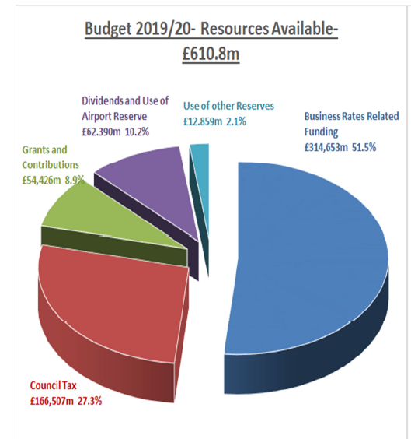
Figure 1: 2019/20 Resources Available
And how much money does it spend in a given year?
Well, another time let’s talk about the difference between revenue (Running costs expenditure –
under 1 year of useful life, employee costs, maintenance and repairs, utility bills, supplies and services) and capital (new build, renovation, new vehicles and infrastructure) budgets. On the revenue side the budget was £666m (see Figure 1 - There are no pie charts for 2020-21, so that will have to do).

And that’s a lot?
Not really - and it is a lot (several hundred million) less than ten years ago, when the austerity axe started swinging following the subprime mortgage lending banker-induced Global Financial Crisis of 2008.

What does it spend £666 million on? Gold-plated troughs for all the elected snouts? First class travel to Edinburgh for pampered bureaucrats?
What did I tell you about believing the Daily Mail and activist websites, eh?

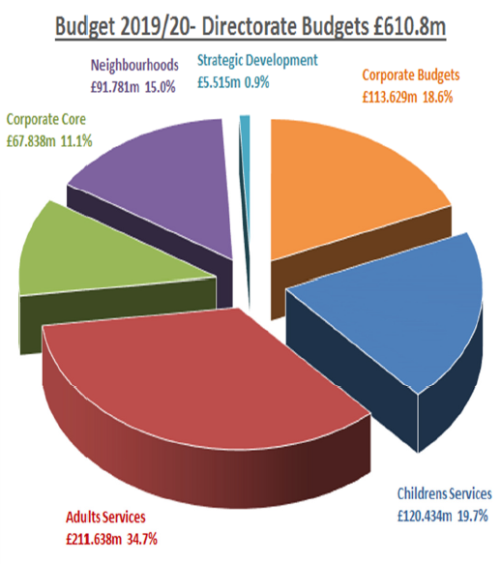
Figure 2: 2019/20 Directorate Budgets

How does this setting-the-budget process usually work? Does the City Treasurer lock her team in a room in Castle Grayskull and slide pizza under the door in exchange for completed spreadsheets, pulling an all-weeker ahead of the deadline set by the Government?
It’s a little more complicated than that. See Figure 3, lifted from the guide for new councillors.

So, what usually goes wrong?
Usually backbench councillors complain that they receive bad papers too late to have any meaningful input...
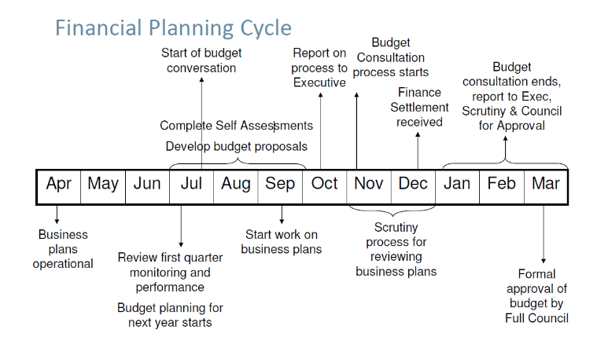
Figure 3: Financial Planning Cycle

So, no change from the rest of the policymaking process then?
Very droll. Also, trying to budget Adult Services is like nailing an ever-expanding jelly to a wall (due to an aging population and increasing health issues), and has to be bailed out by increased savings elsewhere.

What does the budget, set a million years ago (i.e. February-March) say?
It was pretty similar to 2019, in large part because Her Majesty’s Treasury, befuddled by Brexit, didn’t release the details of what everyone would get, in time for there to be a three year budget.
What has happened since then?
The impacts of coronavirus has meant a huge increase in expenditures, disruption to functioning (had to spend £322k on IT). The airport dividend is okay for this year, but probably toast for the next few years (or forever?). Central government has released some money to Local Authorities (Manchester has got £182m), but to paraphrase Captain Brody from Jaws “we’re gonna need a bigger bailout.” What is being proposed at the minute is bolting on some additional government grants to the existing budget (Figure 4).

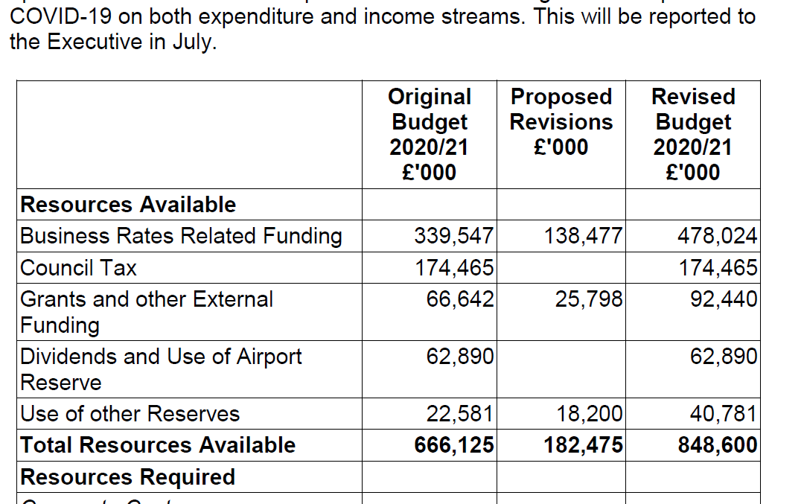
Figure 4: COVID-19 income & expenditure
But this is by no means the end of the story.

What is happening now/next?
The Council is trying to figure out how to avoid triggering a Section 114 notice by balancing the budget. If they can’t, it would cause pretty much ALL spending to cease outside of statutory services (health, social care, waste). Papers are being drafted by the Deputy Chief Exec’s team. Some decisions are being made by her plus the Executive Member for Finance. The Council Executive meets on 3rd June, then there is some scrutiny, and at 3rd July 2020 Executive meeting, “final” decisions will be made.

Look, why does this budget thing matter?
The decisions made over the coming months will shape the city and the (lack of a meaningful) response to climate change for decades.

What is the worst thing the Council could (i.e. will probably) do?
You mean besides bailing out the Airport to keep local jobs for now, but they’ll still be at risk and it’s also in defiance of reducing harm from global heating? You mean besides continuing to make undemocratic decisions about allowing skyscrapers already repeatedly refused by elected representatives? Besides that? Well, probably trying to bounce BACK rather than forward. See our joint response with Steady State Manchester, Greater Manchester Housing Action and Rising Up Manchester Families! to the Local Plan for more about this.

What are the key dates coming up?
Weds 3rd June 2020, 2pm for a(virtual) executive meeting of Manchester City Council. Papers / webcast.
Monday 22nd June 2020, at 7pm Climate Emergency Manchester’s next monthly meeting.
Weds 24th June 2020 for a special GMCA meeting about the financial implications of the Coronavirus.
Friday 3rd July 2020 for (virtual) executive at which a new budget (but seriously - this shitshow is going to run and run) is approved. Before another one, we would guess before the end of the year.

How can I move from novice level to practitioner level at this?
Buy the Manchester Evening News and read the articles about the budget process carefully. There are some good journos doing their best under horrible conditions.
Stay tuned for the next (longer) bluffer’s guide, which will come at you soon. Ask us questions (we may not know the answer). Check out our website
What is some of the jargon I should be beginning to get my head around?
Well, we’ve run out of space - see here.

*Novice and practitioner level is a reference to the Active Citizenship Toolkit, which CEM and allies are developing. See here

[Version 1.0 2nd June 2020 Text by Marc Hudson. De-snarking by Adam Peirce]

www.climateemergencymanchester.net
@climateemergmcr

