We really can't do this alone, or as some vanguard waiting for others to fall into 'line' under our 'leadership'. So, if you want others to help you, you have to help them. That requires understanding (while not necessarily always agreeing) with their view of the world and taking practical steps to help them in making their lives better, and help them with their campaigning. Failing to be an ally means you have no credibility, in your own eyes, or in other people’s.

Wait, what has fixing climate change got to do with being an ally in struggles for justice around race, class, gender? Why do you always have to import some Lefitst social justice warrior agenda?
Most of the people on this planet are not white. So right there, if we’re talking about our species, you’re going to want to think about what is happening to those who are not white and living in the west. Climate change is already affecting many people on this planet, thanks to changes to weather patterns (nastier heatwaves, droughts, sea level rise, changes to agriculture). Those on the sharp end of these changes tend to be poor people of colour (though to be clear - money only offers some protection, and it will not forever).
But from a purely “practical” point of view -
a) there is a wealth of knowledge in those communities about how to survive in horrible situations, and how to work together to change them. It makes sense to benefit from that.
b) if you want system change (and we really really need system change) you are going to have to work with many different kinds of people(s). They are not going to want to work with you if you are ignorant, selfish and mired in your own unexamined privilege and cannot provide effective allyship. Get a grip FFS.

Well, for the sake of argument, let’s say you have a point. What does that mean in practice, where I live? I mean, I can’t do anything about President Trump. Is there a book I can read, a course I can take that means you’ll get off my back?

Oh dear. Quite a few Is and mys there. This isn’t about you. This isn’t about you getting some “good climate activist badge” and a parade.
But I heard you banging on about an ally!
Hmm we prefer “Currently operating in solidarity with.”
Why did you come up with something so clunky?
We didn’t. That belongs to Mia McKenzie-
https://charterforcompassion.org/peace-building/no-more-allies
Andy because not only is the idea of “arriving” at “being an ally” dodgy af, the whole performing allyship thing is dodgy af.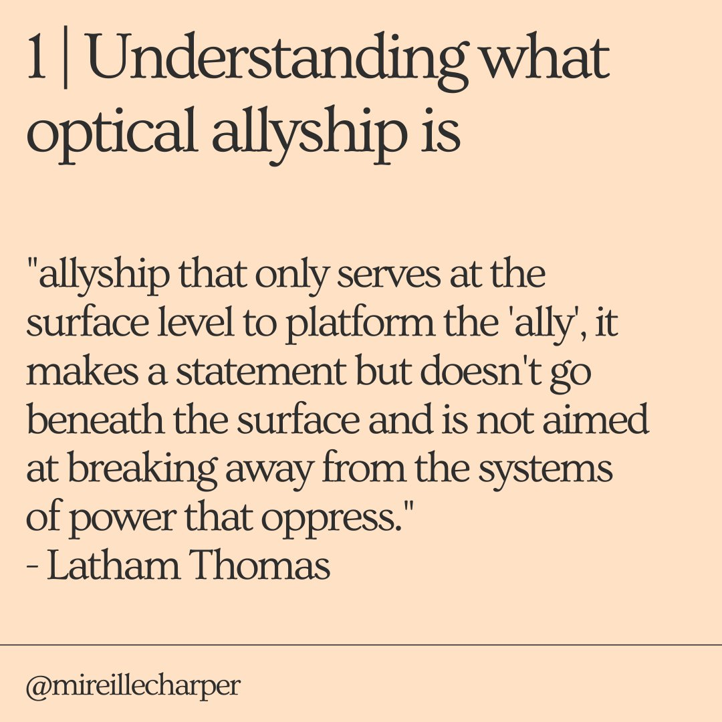

So, there’s no single book followed by a badge?
Sadly no. It turns out the struggle for a better world is not easy and convenient - who knew? Fortunately, there are lots of great guides - written by people of colour for the most part - about this very topic. if you want it boiled down into 10 tweets, then this https://www.vogue.co.uk/arts-and-lifestyle/article/non-optical-ally-guide

Google “how to be an ally” and better “how to practice allyship” there’s loads of stuff. And CEM will be doing a much longer guide than this soon. People of colour have already given us loads of good ideas when looking at a draft of this.
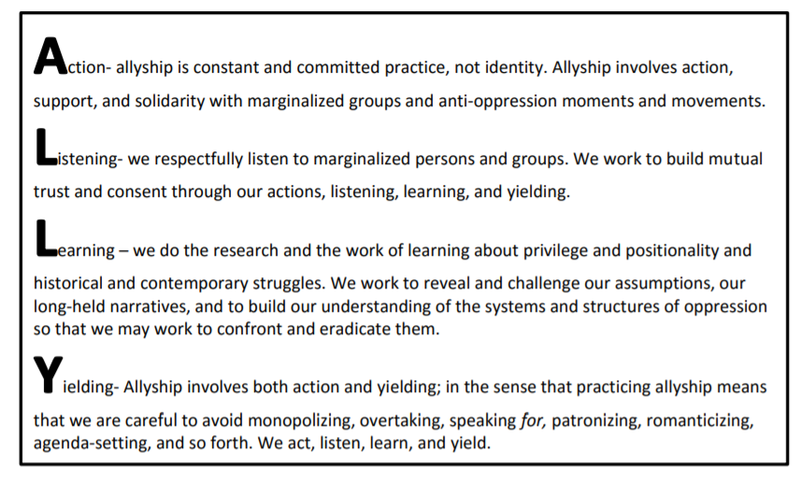
From here

So, what does this mean, in practice?
We think at least the following-
Listen. Two ears, two eyes, one mouth. That’s a 4:1 ratio right there.
Amplify other voices that (weirdly) don’t get amplified by the mainstream media, by mainstream culture.
Use your damn privilege. If you have the benefit of lots of education, if you have got lots of skills and knowledge, then FFS you have to SHARE them, in humble ways (pro-tip: sharing does not mean telling people that you are the boss and they have to listen to you). Confront white racism (not just your own), with firmness, diligence, compassion, knowledge etc
Do the work yourself. Never demand/expect emotional or intellectual services from categories of people who you want to display (ooh, that word is doing so much work in this sentence!) allyship to. Do damned work: do the reading, the watching, the thinking yourself. Find other white people to do it with, consistently, regularly..
Stay critical. There is no monolithic answer to the crises which beset us all. There is no One Right Way. People of good intent and similar experiences will have different takes on what is going on and why, and what is to be done.You can’t just abrogate your responsibility for your own behaviour.
Don’t expect good guy tokens
Understand that you will screw up (because you will) but that your tears help nobody, and they centre you, derail other conversations
Share whatever skills you have
Plan to do this for the long haul. That means assigning resources, creating a system to monitor what you are doing, how well you are doing it.

Some key reading
Gay, R. 2015. On Making Black lives Matter
https://www.marieclaire.com/culture/a21423/roxane-gay-philando-castile-alton-sterling/
Heglar, M. 2019, Climate Change Isn’t the First Existential Threat
https://zora.medium.com/sorry-yall-but-climate-change-ain-t-the-first-existential-threat-b3c999267aa0
Kendall, F. 2003 How to Be an Ally if You Are a Person with Privilege
http://www.scn.org/friends/ally.html
Lorde, A. 1981. The Uses of Anger. https://academicworks.cuny.edu/cgi/viewcontent.cgi?article=1654&context=wsq
Philips, H. 2020. Performative Allyship Is Deadly (Here’s What to Do Instead)
https://forge.medium.com/performative-allyship-is-deadly-c900645d9f1f
Wiseman, R. 2019. Colonialism + capitalism = climate crisis. https://www.globaljustice.org.uk/blog/2019/oct/7/colonialism-capitalism-climate-crisis

Guide to Allyship
https://guidetoallyship.com/

Key concepts
Decentering - this isn’t about you. See also white tears, white saviour complex.
Optical Allyship - see above
White Fragility - (why white people freak out and can’t talk or think clearly) Robin DiAngelo newspaper interview and podcast interview
White Saviour Complex - see here.
White Saviour Industrial Complex - see here.
Whiteness Studies - see here.
White Tears - see here.

How can I move from novice level to practitioner level* at this?
We’re going to try, sharing and learning as we go. We will write a longer guide...

[Version 1.0 5th June 2020 Text by Marc Hudson. Thanks to P for her helpful comments]

*Novice and practitioner level is a reference to the Active Citizenship Toolkit, which CEM and allies are developing. See here

www.climateemergencymanchester.net
@climateemergmcr

