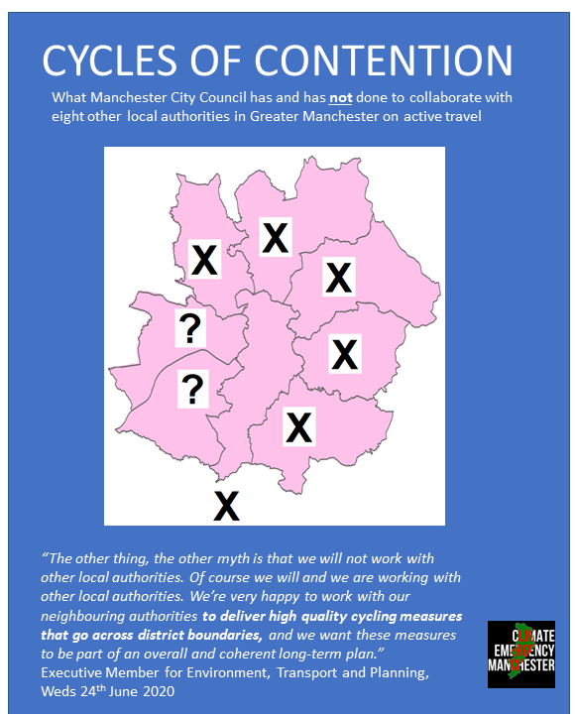

Contents
Executive Summary 2
Thanks and acknowledgements 3
Introduction 4
Methodology 4
Key findings 6
Manchester City Council’s responses. 6
Other councils’ replies 7
Hyde Road shenanigans and blame-shifting by Manchester City Council 11
What it all means, and what is to be done? 13
About CEM 14

Executive Summary
If you don’t have a car, then your choices for getting to work or wherever you need to get to are stark You either take your chances on the buses and trams (hoping you won’t get coronavirus and then pass it on to your loved ones), you walk, you take your chances cycling on roads where there is little or no provision, or you don’t travel at all.

There is an injustice in this - we as citizens should not be facing greater risks just because we don’t own cars.

You would hope that the Labour-dominated Manchester City Council (MCC) would understand that the provision of safe and accessible infrastructure for active travel was a straightforward social justice issue.

However, the results of this report show that the Council, if it does understand this, shows little (i.e. no) appetite for behaving boldly or imaginatively around “pop-up cycle lanes” over the last few months. The following pages reveal, in painful detail, that MCC has done sweet FA to work with other local authorities to make pop-up cycle lanes “a thing.”

We submitted specific Freedom of Information Act (FOIA) requests to Manchester City Council and also the eight local authorities it shares borders with. From MCC we got the briefest and most inaccurate reply. From other councils we got - usually - more helpful responses.

This report therefore also shows that when presented with opportunities to talk about what it has done, to puncture what it would like to label “myths”, the Council has refused to release information, and has treated citizens and their rights to information with contempt.

There is a heart-breaking lost opportunity here and another example - as if more were needed - of the inability of Manchester’s current leadership to act with transparency, imagination and intelligence in the interests of its citizens.

We urgently need new mechanisms by which proper scrutiny of existing policies and fresh thinking can be applied. One way for that to happen is via the creation of a seventh scrutiny committee, dedicated to climate and environment policy. Climate Emergency Manchester has begun a petition for this. Anyone who lives, works or studies within Manchester City Council’s boundaries can sign it. You can sign it online here.

Alternatively, you can download a copy of the petition sheet from here, fill it in (and get other people you live with to add their details) and then email us and we will come and collect. We are also hoping you will invite us to speak at any online meetings you are holding.

Thanks and acknowledgements
Thanks to all those who sent in FoIAs, helped with the proofreading and the layout.
Thanks to those who have lobbied their councillors for better active transport provision.
This report is dedicated to those who have lost their lives on Manchester’s unsafe roads, and to those whose lives are being cut short by unacceptably high levels of air pollution. Ultimately, of course, we all are suffering, and will further suffer, the consequences of air pollution and unmitigated climate change.

Cover map adapted from the following source
By Nilfanion, CC BY 3.0, https://commons.wikimedia.org/w/index.php?curid=32880738

Introduction
On Wednesday 24th of June 2020, with the question of pop-up cycle lanes already a live issue on social media and even on billboards in Manchester, two things happened:
Firstly, in the morning, a group of XR Manchester people laid out their own pop-up cycle lane, connecting Trafford’s existing scheme and Manchester. By the evening the Council had removed it.
In the afternoon, the Neighbourhoods and Environment Scrutiny Committee met. This committee, made up almost entirely of Labour councillors, has transport within its remit. Many many residents of Manchester had contacted the councillors on the committee, asking that the question of pop-up cycle lanes be raised as a separate item of urgent business. This was not accepted by the chair, and ultimately a separate meeting occurred, behind closed doors, uniminuted. However, within the NESC meeting, the Executive Member for Environment, Transport and Planning made a series of statements. The crucial one is this, at exactly 22 minutes into the recording of the meeting.
“The other thing, the other myth is that we will not work with other local authorities. Of course we will and we are working with other local authorities. We’re very happy to work with our neighbouring authorities to deliver high quality cycling measures that go across district boundaries, and we want these measures to be part of an overall and coherent long-term plan.”
It is on that basis, after repeatedly asking for clarity from the Executive Member for the Environment, and after trying and failing to get the Neighbourhoods and Environment Scrutiny Committee to take its role of scrutinising the (lack of) action on pop-up cycle lanes seriously, that Climate Emergency Manchester resorted to the Freedom of Information Act.

Methodology
Separate requests were submitted to Manchester City Council by eight different individuals.
Other FOIA requests were sent to other eight local authorities.

The FOIAs sent to MCC were as follows -

Dear Sir/Madam,
I noted with interest that during the Neighbourhoods and Environment Scrutiny Committee meeting of 24th June 2020 the Executive Member for the Environment made a number of assertions about pop-up cycle lanes. I am specifically interested in the statement that Manchester City Council is actively collaborating with the other local authorities on provision for active transport, since the facts on the ground don’t seem to match this claim.

To make this specific, between May1st 2020 and June 27th 2020, what discussions have been held between relevant actors (officers and elected members) of Manchester City Council and xxxx Council.

Please provide copies of the correspondence between these actors.
I am particularly interested in examples of where Manchester City Council has been proactive in engaging with xxx Council to make pop-up cycle lanes part of a ‘joined up’ experience for all types of cyclists - commuter, leisure, other purposes, especially those who are not necessarily able-bodied.

I note that while the Council does have the legal right to delay providing this information for 20 working days
- There is enormous public interest in this matter, and the Executive Member has recently publicly accused campaigners of spreading “fake news” and “myths”. Providing this information more quickly would make such “myths,” if that is what they are, untenable.
- Answers to a recent FOIA about the Council’s relations with NCP, formulated to allow the Council to disprove false insinuations about the Executive Member for the Environment, were provided in 36 hours (not working hours, hours full stop). This would suggest that when there is political will, things can be done very quickly (just ask XR Manchester).

Please consider this a request under the Freedom of Information Act 2000.
Your name
Your address

The requests to the all the other local authorities, bar Salford, were as follows

Dear Sir/Madam,
I am interested in your council’s plans and actions for cycle lanes and active travel (e.g. for pedestrians) on all routes which cross over into the territory under the responsibility of Manchester City Council.

- Please could you tell me what routes these include, and what actions your council has taken to make cycling provision and active transport more possible during the coronavirus lockdown (e.g. “pop-up” cycle lanes) on these routes.

- I am also interested in what communications you have had with Manchester City Council and the state of any coordination and collaboration with them (or of course lack of coordination/collaboration). Specifically, for the period 1st May to 27th June 2020

- If communications on the specific question of the provision of pop-up cycle lanes along cross-authority routes did not already exist, which council (yours or MCC) initiated it, on what date and how?

- Please provide copies of all correspondence (emails, texts, minuted phone calls, snail mails, decrypted whatsapp etc) between the two councils about the provision of pop-up cycle lanes/active transport on cross-boundary routes for the above dates, inclusive.

Please consider this a request under the Freedom of Information Act 2000.

Key findings

Manchester City Council’s responses.
Manchester City Council waited the maximum number of days allowed (20 working days) before replying to all* requests with identical replies.
“The Executive Member for Environment, Planning and Transport has confirmed discussions took place regarding emergency active travel with other local authorities. However, the details of conversations were not recorded and so the Council does not hold this information.”
What is intriguing in this is just how unspecific it is. As shall be seen, in many cases it simply does NOT tell the truth in response to the specific questions that they were asked with regard to a specific local authority.

*One person who submitted a request received no answer. Upon nudging the Council they were told that a reply had been sent. They checked their spam folders and found nothing. It may well be that Manchester City Council was overwhelmed by the complexity of replying to eight different people.

Other councils’ replies
Six of the other councils gave informative replies. The crucial text is in bold. Two councils were less helpful. Salford tried to claim that TfGM held the information, and Trafford has not yet replied.

Bury
Bury’s reply was admirably quick - submitted on the 29th June, with a reply received on 30th June.
“Bury Council currently has no plans in place for active travel measures which cross over the Bury/Manchester administrative boundary. Consequently, no communications have taken place between Bury and Manchester on active travel measures.”

Oldham
- Please could you tell me what routes these include, and what actions Oldham council has taken to make cycling provision and active transport more possible during the coronavirus lockdown (e.g. “pop-up” cycle lanes.)

“We have no plans for the routes that cross the Oldham-Manchester boundary.”

2) I am also interested in what communications you have had with Manchester City Council and the state of any coordination and collaboration with them (or of course lack of co-ordination/collaboration). Specifically, for the period 1st May to 27th June 2020.

“We have had no communications with Manchester City Council over the period 1st May to 27th June 2020 regarding routes that cross the Oldham-Manchester boundary.”

3) If communications on the specific question of the provision of pop-up cycle lanes along cross-authority routes did not already exist, which council (Oldham or MCC) initiated it, on what date and how?
“Not applicable – see response to Q2) above.”

Rochdale
Their reply is as follows
“To date, Rochdale have been monitoring the network during COVID restrictions and considering where and when temporary or popup infrastructure may be useful on the network.
There are no communications on record for the time period specified between Rochdale and Manchester Council regarding crossborder walking/cycling routes.
Officers from both Rochdale and Manchester have collaborated previously on ideas for
walking/cycling and general highways issues and will continue to do so in the future on any improvements that could be made on the network.”

Stockport
I am also interested in what communications you have had with Manchester City Council and the state of any co-ordination and collaboration with them (or of course lack of co-ordination/collaboration). Specifically, for the period 1st May to 27th June 2020

“We have no correspondence on file from Manchester City Council regarding this matter. Any information regarding this may form part of strategies as part of the wider Transport for Greater Manchester schemes, in which case information would be held by Transport for Greater Manchester”

If communications on the specific question of the provision of pop-up cycle lanes along cross-authority routes did not already exist, which council (Stockport or MCC) initiated it, on what date and how?
“No information held.”

Please provide copies of all correspondence (emails, texts, minuted phone calls, snail mails, decrypted whatsapp etc) between the two councils about the provision of pop-up cycle lanes/active transport on cross-boundary routes for the above dates, inclusive.
“No information held.”

Cheshire East
“There is a limited direct border between Cheshire East Council and Manchester City Council with only Styal Road crossing the border. The other main transport corridors into Greater Manchester are currently the focus for providing improved walking and cycling routes. As a result no correspondence has occurred with Manchester City Council on this matter between 1st May to 27th June 2020.”

Tameside
As per our blog post on Climate Emergency: On 12 June the head of Engineering Services at Tameside Council emailed someone (we don’t know who, their name is redacted) at Manchester City Council. The Tameside officer had already tried contacting this Manchester officer by phone. They wanted to discuss extending the improvement of walking and cycling facilities into Manchester city centre.
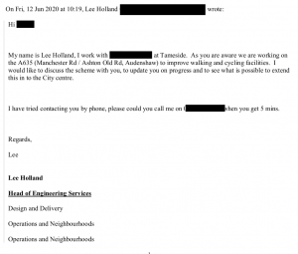
Seven minutes later came the reply. Manchester is “not proposing any pop up cycle lanes at the current time.”

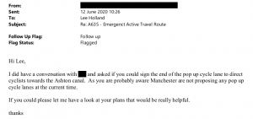

Trafford
Trafford has not yet replied to the Freedom of Information Act request. They have been reminded of their legal obligation. If and when a reply is received, it will be noted on the Climate Emergency Manchester website.

Salford
Salford Council was asked the following-
I would like to request information regarding any collaboration Salford City Council has had with neighbouring councils regarding provision for active transport between March 1st 2020 and the present date.
The information would include what discussions have been held between relevant actors (officers and elected members) of Salford City Council and Manchester City Council, and also Bolton and Wigan councils.
Please provide copies of any correspondence between these parties on the subject of transport, with regard to cycling, walking, child-friendly and disability provision, especially in the light of pandemic changes.
I am interested in examples of where Manchester City Council (or other councils) have been pro-active in engaging with Salford City Council to make pop-up cycle lanes part of a joined up experience for all types of cyclists - commuter, leisure, other purposes, especially those who are not necessarily able-bodied.
The reply (and we are quoting it in full) was this.
“This information is held by Transport for Greater Manchester TfGM available on the link below https://tfgm.com/foi”

So, in summary, there has been the grand total of one email from Manchester City Council to a neighbouring Local Authority, Tameside (and this only after its officer had tried to phone MCC).
There has been ZERO effort to reach out to other local authorities which share borders with Manchester City Council. ZERO.

Hyde Road shenanigans and blame-shifting by Manchester City Council
This text below is from a brilliant blog post by Sam Tate. Six months ago he revealed that Manchester City Council had deliberately misclassified comments which expressed profoundly disagreement with a road-widening scheme as "neutral" to make it seem more popular than it really was. On Thursday 13th August he posted a detailed blog post. We have cut and paste the following excerpt.
https://samvironment.blogspot.com/2020/08/hyde-road-6-months-later.html
Let's ignore that, and focus on WHY funding was not available to deliver basic pedestrian and cycle safety. A quote from the same response reads: "We applied to the Greater Manchester Mayor's Challenge Fund for funding to include a cycleway in this project, but unfortunately, this bid was declined"
This is a line the council has used a lot for this scheme, and we touched on this in my last post, linked above. It seems the wording of this is carefully written to shift the blame to GMCA/TfGM for not providing the funding, rather than to MCC for not producing a good enough bid to secure the funding. As I mentioned in my previous post, I got hold of the bid document and it was rather poorly written with typos and missing/incorrect information. Therefore I decided to FOI Request more info from TfGM as to why the bid failed, the response to which can be seen here.
TfGM sent over several documents regarding MCC's bid for funding from the Mayors Challenge Fund to implement basic walking and cycling safety features alongside the widening scheme. The first of which can be seen below, an excerpt from an email from TfGM to MCC advising that the bid would not succeed in its current form due to a lack of integration into the wider network, and very poor value for money, asking ten times as much per kilometre as the Wilmslow Road cycleways.
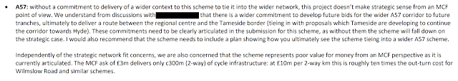

Another document outlines a similar story, that MCC had made little to no effort to demonstrate how the scheme would tie into the wider network. The Fallowfield Loop runs on the bridge above and was proposed to have just stairs for access with a wheeling ramp. Of course as we know, after people complained that stairs aren't accessible to all, MCC have since removed them from the plans completely so everyone is equally disadvantaged. There also appears to have been little to no evidence of MCC getting in touch with Tameside to link this scheme to the Tameside ambition of having the whole A57 walking and cycling friendly.

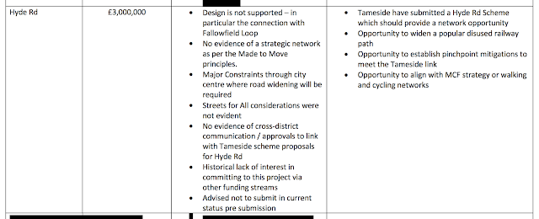

This document makes it clear that TfGM explicitly advised MCC that the scheme would be unlikely to succeed in the current form, and yet it appears it was submitted like this anyway. It seems that the submission of this scheme might therefore only be so that MCC could state in future announcements that they had applied for funding but it was declined (which is exactly what they've been doing). It appears to me that TfGM explained clearly what MCC needed to do to give this bid a better chance at succeeding and it appears little to nothing was done. Therefore it cannot be a surprise to MCC that the bid failed and any attempt by themselves to shift blame onto TfGM for this failure is cynical and unfair.

What it all means, and what is to be done?
The “leaders” of MCC are trying to have it both ways; complaining about “myths” but then not revealing information, and ludicrously waiting the full 20 days before releasing a non-information reply. The kind of contempt for democracy that people have come to expect from Michael Gove). At the same time it seems clear that MCC’s Highways Department clearly needs a root-and-branch overhaul.

What is to be done?

Backbench councillors, especially those who sit on the Neighbourhoods and Environment Scrutiny Committee have to ask themselves a few questions
- Do they think the way the Executive treats them is healthy for them, healthy for democracy?
- Do they feel that they as backbench councillors can represent the interests of voters in such a culture?
- What will they DO about that culture?

Citizens need to decide whether they will tolerate such naked contempt for democratic processes of scrutiny.
If they will, the solution is simple. Do nothing and the status quo will be sustained.
If they will NOT tolerate such abuses, they need to commit to changing how things are done in Manchester

They should:
- expect a long battle and prepare for it. This means being part of functioning groups with a range of skills and knowledge, and a commitment to helping other people be involved for “the long haul”
- understand that we need new democratic structures, such as - but not limited to- an additional scrutiny committee.
- understand one of the most effective and dangerous tools in the arsenal of those who want to keep things the same is the impression that nothing can ever change, that, “that’s just the way it is.” This is not true.
We can do better. We must do better.

We have missed the boat so far with pop-up cycle lanes and cross-boundary co-operation. Other opportunities will come. If we want things to be different in the future, we need to start behaving differently now.

About CEM
Climate Emergency Manchester is a non-partisan group campaigning for better policies around climate change, and better implementation of existing policy.

We believe that responding to climate change requires a diverse range of responses, and that the last ten years have been missed opportunity after missed opportunity.

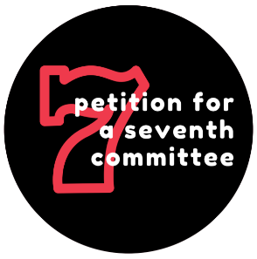
We have a petition for a seventh scrutiny committee which anyone who lives, works or studies in Manchester can sign
We need your help to get more signatures on this.
Please download a sheet and get those you live with (if you live within the City Council’s boundaries) to sign, then email us and we will come collect.
Please invite us to participate in any online meetings at which we could talk (briefly) about the petition campaign.
Please come out “sandwich boarding” with us (we have a QR code, we’re going to walk around various places with it on a big sandwich board. It’s more fun than it sounds).

We also have a growing “Active Citizenship Toolkit”, to help individuals and groups figure out what skills, knowledge and relationships they have and they need, and how to close the gap.

You can find out more about us via our website climateemergencymanchester.net
You can contact us on contact@climateemergencymanchester.net
You can follow us on Twitter on @climateemergmcr

