Petition Taskforce
Team Manchester saves the world*
Handbook version 1.0, 7th September 2020

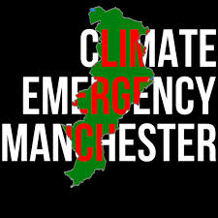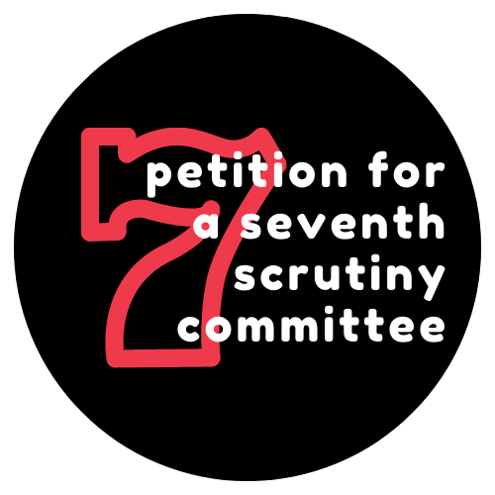
*Actual facts may vary, always read the label.
Table of Contents
Contents
Introduction 2
Manchester city council and climate: a VERY short introduction 3
Our thinking about the petition - (why it came into existence) 4
The dangers in a petition 4
Our thinking about “how to get there” (hint, involves you) 5
Who can sign and how? 5
Mechanics of the collecting process 7
Target audiences 7
Online action 7
Offline action 8
Principles for you being involved 9
Induction of individuals 9
Weekly petition task force meetings (online) 10
Ongoing work 10
What skills and knowledge do you need? 11
Generic Skills and knowledge we could all gain (practitioner at least by the end of the process) 11
Specialised skills we would help you develop 15
Final thoughts 19

Introduction
Hello. Thank you for agreeing to be part of the Climate Emergency Manchester petition task force. It cannot be said enough how much we value your support.

This ‘handbook’ is designed to help you understand where we are coming from and puts much of the key information about the petition in one place. The document is therefore partly a reference point and will mean that you don’t always need to keep asking us questions.

In the second half, we set out some of the ways in which you might develop your own skills and knowledge through working with us on this campaign. If we are all learning, and maybe even having fun, this will be a victory no matter how many signatures we ultimately get.

Please read all of the handbook, so that you are up to speed…. And so that you can tell us where we are wrong. It’s not too long and there are cartoons!

Manchester city council and climate: a VERY short introduction

You can use and tweak this if/when talking to others about the petition. Much more detail is of course available on the CEM website (www.climateemergencymanchester.net) and you can always talk to one of us in the core group if you have a query on a particular point.
Manchester City Council is in an endless loop of making shiny promises and then not taking the action to keep them. On environment policy this dates back to the mid-1990s. On climate policy, this dates back to the late 2000s. Then they said they would cut emissions (emissions have gone down, but mostly because of austerity and the UK burning less coal to get its electricity)

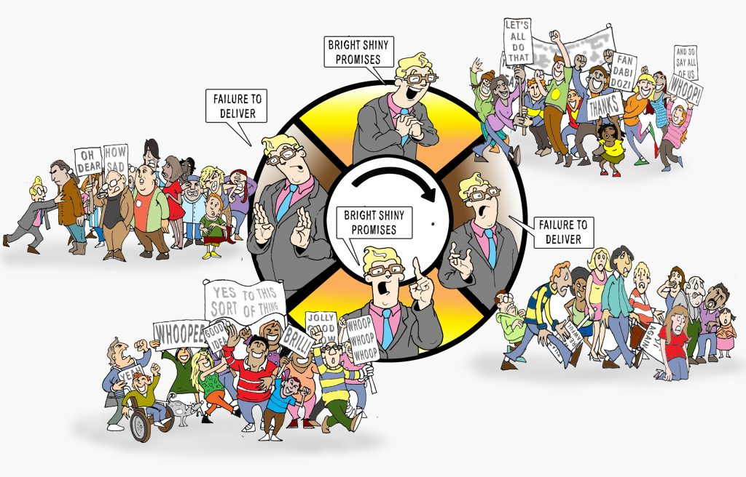

In March 2019 Climate Emergency Manchester began as two citizens, who launched a petition on the City Council’s website for the Council to declare a climate emergency. That petition was one factor - not the most important, but definitely one factor - for the Council to declare a climate emergency in July 2019 (the others were the school strikes, XR, and - perhaps most importantly- most of the other big cities in the UK declaring a climate emergency.
We know, then, that in the right circumstances, a petition can have an effect.

Since then, the cycle of promises rather than action has continued. Although the council launched more plans throughout 2019 and 2020, since declaring a climate emergency it has done precious little.

Our thinking about the petition - (why it came into existence)

At the beginning of this year (i.e. a million years ago) the core group of CEM agonised about whether to launch another petition. They are bastard hard work.

In the end, we unanimously decided to do so, in part because we could not think of a better way of breaking the cycle of promise-not deliver than having an official, “internal” scrutiny committee. Maybe there are better ways forward, but we still don’t see them.

Of course, there are other ways to get a seventh scrutiny committee. We could have done “behind the scenes lobbying”. Even if that had a snowball’s chance in hell of working, we would have been reluctant, because that really IS begging (see below) and would have left us less powerful and useful than at the outset.

Ultimately, we want Manchester to have a vibrant, knowledgeable and genuinely independent civil society response to climate change. One that isn’t fooled by foolish PR spin, that isn’t hopelessly inadequate and hopelessly compromised.

We think that a petition campaign is one way (not the only way) forward to achieve this EVEN BIGGER goal, and try to keep it in mind at all times.

We had a viable plan to collect signatures between February and August. In the first few weeks of the campaign we collected 250 online and 509 on paper (actually many more..., but some of them were definitely not valid - see below). Then, well, coronavirus.
We got an extension to November 10th. We’ve been collecting online and have begun to shift the momentum - we now have 411 online, and a few more on paper. We believe we have a pathway to getting the rest by the deadline (we might of course be over-optimistic). Now is the time for the push.

It’s worth noting that since the beginning of 2016, which is when the Council displays records for, no other e-petition besides our first one (497) even got into triple figures…

The only petition we are aware of that EVER got over 4,000 signatures was one resulting from a big campaign financed by the MEN to remove an ugly wall in Piccadilly Gardens. No community group has ever got as far as we have already got. WE ARE UP FOR THE CHALLENGE.

The dangers in a petition
We are very aware of the dangers of a petition. It can be tiring and, unless we are supporting each other, demoralising. The outcome is not certain, which is why we will keep banging on about acquiring new skills along the way, and building a stronger civil society in the process.

(Also, it’s begging, isn’t it? Instead of getting out there and “doing it ourselves”. But we ARE getting out there and doing the scrutiny ourselves. It’s exhausting and demoralising and probably unsustainable in the long-term. Also, it means that Councillors don’t do this themselves as much, it doesn’t become normalised as something all councillors “do.”)

Our thinking about “how to get there” (hint, involves you)
In this section we explain how we think it is possible to get 50 signatures a day for each of the next 60 days.

We REALLY want your critiques of this plan. Where is our reasoning flawed? What opportunities are we missing? Where are we being overoptimistic?

First up, some basic factual guidance.

Who can sign and how?
Eligibility
Anyone of any age who lives or works or studies within the City Council’s boundaries can sign.

- A 12 year-old who lives in Trafford but goes to school in Manchester can sign.
- An EU citizen who works in Salford but lives in Ancoats can sign.
- Someone who lived in Manchester City Centre for 30 years who just moved to live and work in Oldham… can NOT sign.
Ways of signing
EITHER signing online OR signing on paper
Online is a ball-ache, but has the advantage that it shows up as “official”
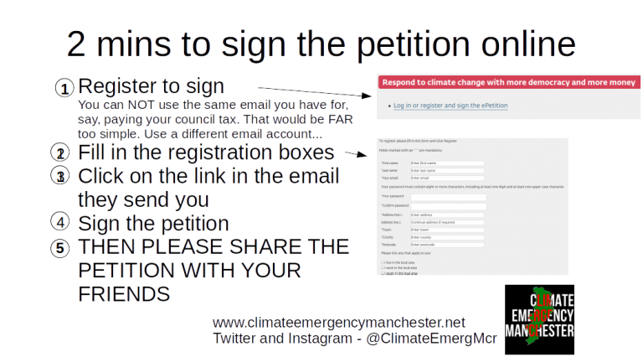

Signing on paper is slightly more difficult - with the risk of “invalid”, but we think doable in large numbers.

People have to write their name, sign their signature, then circle either live work or study and then GIVE THAT ADDRESS which is within the City Council’s boundaries.

We have come up with an advice sheet around this, back when it was possible to be within two metres of folks. But the general stuff about eligibility is key.
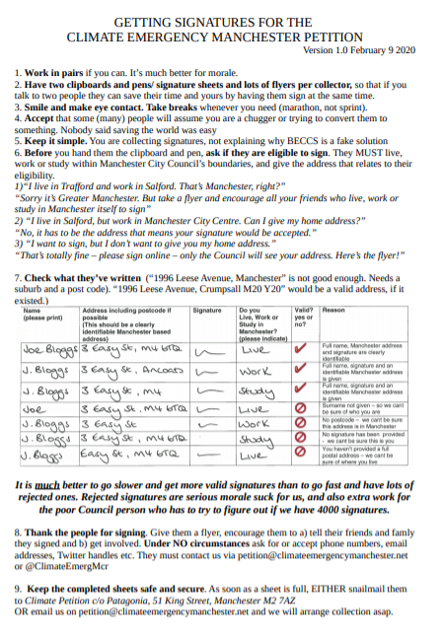

Mechanics of the collecting process

Target audiences
We really really wanted to get this 4000 by going geographically all over the 32 wards of Manchester, to show that citizens across the whole city cared about climate change (rather than the mistruth that it is the only concern of certain groups).

In the absence of the coronavirus we could and would have done this. But the situation now is that we have 60 days to get 3000 signatures. That’s 50 a day…

Therefore, we are going to focus on
- Students (secondary school, further education, university)
- “Greenies” and other progressive groups
- Teachers, academics, support staff at schools and universities
- NHS workers of all types.
- Anyone else who will engage with us.

Online action
This is not a complete list of what we are planning. Please also pitch in additional ideas!

1 - Our website
- Every Monday we are going to put up a blog post that explains where things are up to and what we are doing in the next week.
- ALL our blog posts will have a line and a link to the petition, even if it is just a “shameless plug”
- We will have “milestone” interviews every time we hit a round number. (100s)
- We will upload videos of people explaining why they signed the petition at a much higher rate than now.

2 - Other people’s websites
We want to get guest posts both on the websites of the usual suspects (other green groups) but also beyond the green ghetto
Do you know people who run websites that cover either Manchester or environmental issues?

3 -Getting into the email bulletins of organisations large and small
We need to do this so the petition gets under as many noses as possible.

4 - Zoom calls of various groups
Trades unions, religious groups, special interest groups, you name it. We don’t need to stay for the whole meeting, but can say a few words at the start or end of a call.

5 - Podcasts
We want to be invited to speak on these ESPECIALLY beyond the green bubble, e.g. football, city guides, culture, food etc.

6 - Social media
Twitter,
Facebook,
Instagram,
Youtube,
Maybe even TikTok...

Offline action
Again, this is not in order of importance of frequency… and we’d like more ideas. Crucially, if you should be self-isolating (because you feel sick, because you have been in contact with someone who has tested positive, because you have a knackered immune system) DO NOT PUT YOURSELF OR ANYONE ELSE AT RISK.

1 - Sandwich boards with QR codes linking to our petition
This means that people can find out about the petition while remaining socially distanced.

2 - Stalls at outdoor markets and events
Our stall at Levy market on 5th Septmeber was a roaring success. We’re now actively looking for other events. Do you know of any? Would you like to do 30 minutes research into what is coming up between now and November?

3- Getting interviewed on (community) radio stations
Such as AllFM. Let us know if you have any contacts, or ideas!

4 - Media, local and, potentially, national
We have had some success in getting letters published In the MEN. Other ideas welcome!

5 - Other “in real life” activities
This covers posting blank signing sheets into letterboxes on specific streets, asking to collect back. We could also put flyers with the QR code / link to the petition online through letterboxes.

6 - Posters in shop windows and local businesses
These would feature the QR code and an eye-catching design. One of the tasks might be to approach suitable shops / local businesses and ask them to display.

7 - Beer mats
One example of a creative, innovative brainwave is to print the petition logo/QR code onto a beer mat. We have already got the agreement of a number of breweries and pubs!

8 -- Other creative ideas
We are open to all ideas, zany and imaginative. Think: what campaigns have you seen or been involved with that have been successful? What did they do? Why did this work?

Principles for you being involved
So, what does it all involve? Saying ‘yes’ to being involved...
- Does not mean you drop everything else
- Does not mean you have to be involved in all weeks, or that your involvement can’t go up and down (that would be normal)
- Does NOT mean you have to attend weekly meetings (but it would help if you told us what you were going to be able to do, timewise)
PLEASE ONLY TAKE ON JOBS THAT YOU HAVE THE TIME AND SKILL TO DO. And if it turns out you can NOT do a job you said you would. PLEASE PLEASE PLEASE tell us as soon as you realise this. Then we can rearrange, rethink. It’s not a problem. The only problem is when we don’t find out until it is too late to do anything. This is called “lunching out” and it is incredibly destructive of morale and trust. And without morale and trust, we’re completely fucked.

We are not paying you cash, so we want you to learn stuff and we also want you to be a more connected/confident member of “Manchester civil society acting for climate”

Therefore (as we will describe below), we are interested in providing you with specific opportunities to improve your ability at things. You do NOT have to take us up on this. If you’ve no current bandwidth for learning new stuff but are happy to give us time and your current level of expertise, that’s great.

Induction of individuals
Here’s how the process could work.

ONE. You read this handbook, and as you do so, you make notes on things where you think
- We are wrong
- We are missing the obvious problems/opportunities
- The handbook is confusing

TWO You have a think about
a) how much time you realistically have (it would really help us if you UNDERESTIMATE what you will be able to do, so that anything over and above that is a pleasant surprise)
b) What it is you want to do with your existing skills
c) What new skills you want to learn (as per principles above you are allowed to say “none right now, thanks.”)

THREE You send an email to Chloe or Marc via contact@climateemergencymanchester.net summarising this
FOUR You have a one-to-one with one of them about this, ideally BEFORE attending a weekly meeting. (We want you to attend one weekly meeting (they are on Fridays at 3.30pm, online), but you do NOT have to attend more. If you can only do two hours a week with us, it’s if we ask you to spend one of them in a meeting!)

Weekly petition task force meetings (online)
To keep tabs on what is and is not getting done, we’re going to have a weekly meeting, at 3.30pm on a Friday. We will do our absolute best to keep this to an hour (and obviously you can drop out when you need to).
We only want you to attend one meeting if you are busy/allergic to meetings.
If Fridays at 3.30pm are just never going to possible for you (for whatever reason) please let us know and we will find a way for you to feed in (and we’re are always happy to chat one-to-one).
These meetings are about reporting on - and more importantly - planning action on the petition. The more general philosophical questions of what is democracy, what is causing climate change, etc can be dealt with in OTHER meetings (and maybe one day over a coffee/beer).
By the close of play on a Thursday you should have sent in any report that you want to make so the meeting can proceed quickly (people can read quicker than you can talk).

Ongoing work
Throughout the next 60 plus days we are hoping you will take on different tasks, finish them and then tell us if you’re up for another.

The work will fit with what you’ve told us you are up for. Some of it may be boring, and frustrating. . But we promise it won’t be as confusing and soul-destroying as sitting through a scrutiny committee meeting (okay, that’s a fairly low bar).

The work will be related to what skills you have and what skills you want, which brings us neatly to...

What skills and knowledge do you need?

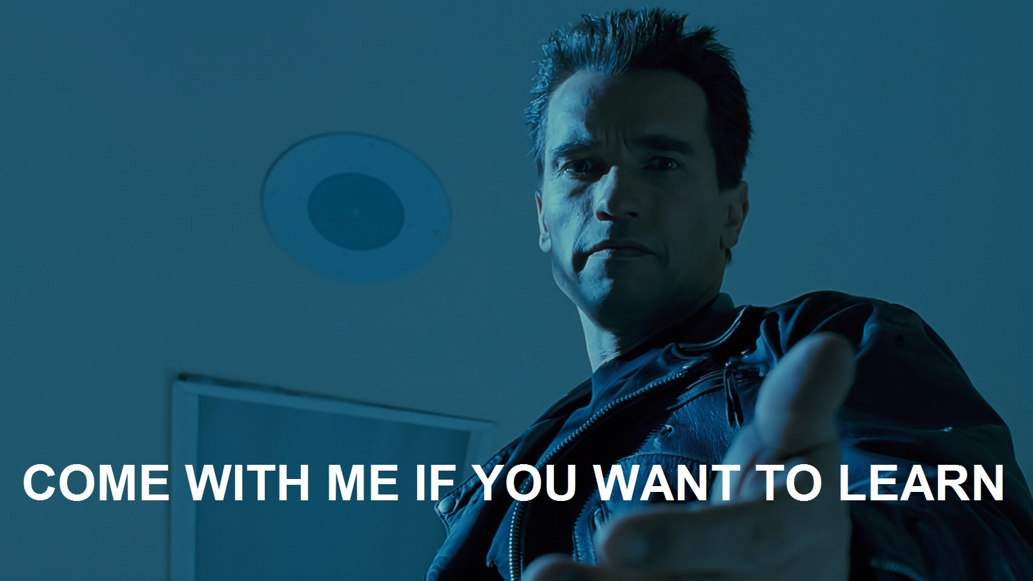
via the Active Citizenship Toolkit

To talk about the skills, knowledge and relationships you need, we’re going to use the terminology of the Active Citizenship Toolkit. You can learn more about that here.

Generic Skills and knowledge we could all gain (practitioner at least by the end of the process)
There are a number of ‘generic’ skills (that is to say, broad and overarching, not tied specifically to petitions about climate change). If you are interested in advancing your skills and knowledge of the below, we would help as best we could. By the end of the petition campaign you’d probably be a solid practitioner at one or two of the following:
- Understanding how Manchester City Council works
- Being able to explain the basics of climate change
- Understanding local climate strategies
- GDPR compliance
- Individual morale maintenance

Understanding how Manchester City Council works
Descriptor: Local authorities are oddly opaque. It's almost as if they don't want the voters to know how they function and how they can be influenced. Crazy, huh? Without that knowledge though, success, however defined, is extremely unlikely.
Level Descriptors
Novice | Practitioner | Expert | Ninja
You can explain the basic political structure of your local authority, and the different types of role elected councillors fulfill. You have a basic grasp on the officers too, and the decision making process | You have a detailed and historically formed ('they used to do it like that, now they do it like this) view of the local authority, its culture, the differences between the official set up and what ACTUALLY goes on. | You know the official story, the real story, where the bodies are buried, how the last reorganisation consolidated the power of THIS faction over that one, how the power games are played, who is good at them and what games are on the horizon. | After an hour in your presence, people fundamentally ' get it', now and forever - the scales fall from their eyes, they understand a panel from a subgroup from a regulatory committee from a scrutiny committee, a directorate from a cold steel rail.,
Here is a useful graphic, by one of CEM’s good friends, Solvi.
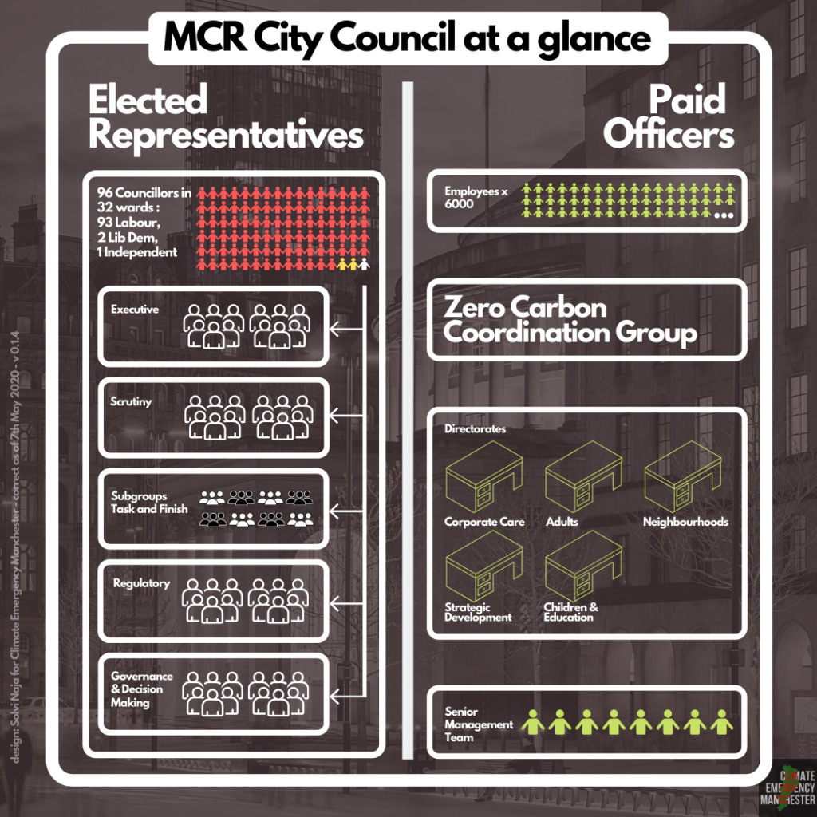
Also in February 2020 we released our “Manchester City Council, and climate change, for beginners” report.

Being able to explain the basics of climate change
Descriptor: Climate science is confusing and intimidating for a lot of people. Being able to explain the basics, and the uncertainties, techniques and models of "climate science" is a crucial skill. Not being able to do so makes you look like a pointless hippy who can be safely ignored.
Level Descriptors
Novice | Practitioner | Expert | Ninja
A work colleague says "I hear so much from so many people, but I don't have a science degree. I have half an hour to sit down - could you tell me the science behind the claims, in simple terms." You can say "yes". You're aware of the basic science, the buildup of CO2, its causes and consequences | Helping your work colleague understand the basics, someone sneers and says "It's all sunspots: I read it in the Daily Mail." You can smile and, with facts, rebut their arguments. You're aware of the denialists lines and lies, their logical fallacies. You can keep your cool when being lied to/condescended... | NB IS THIS A GOOD USE OF YOUR TIME AND ENERGY?? You're able to keep up with the latest science and explain to novices in language they can get what it all means. You can play whack-a-mole with denialist arguments without having to call upon www.skepticalscience.com | Your friend at the BBC phones, ;panicking. Professor Kevin Anderson's flight from London to Manchester is in a stack, so he's unavailable. Can you take on Richard Lindzen and Nigel Lawson in 20 minutes time on Newsnight? You say "duh, of course." You're sending fact-checking letters to Nature Climate Change and Science. You really should get out more, because it is later than you think...

Understanding local climate strategies
Descriptor: Local climate policy is usually full of nice sounding words with no real delivery mechanisms behind it. Being able to understand that, and explain the causes, consequences and remedies for this emptiness is essential. If you can't do all of that, succinctly, why are you even bothering? Seriously?
Level Descriptors
Novice | Practitioner | Expert | Ninja
You know the recent history of climate policy, the headline goals and the current performance of your local authority. The big sources of carbon locally, what is - and could - be done about them. You understand the basic structure of the policymaking apparatus | You have a reasonable grasp on the entire history of climate policy making and (lack of ) implementation in your town/city. You can explain both the trail of broken promises and memory-holed documents, and also the reasons for these failures, and what could still, at this late stage, be done to make the response less inadequate | You have a thorough and detailed grasp of the entire sorry history of climate policy shiny promises, from the year dot. You know why each hype cycle came undone, and can see the patterns, and the influence of local political and policy factors, but also the influence of national and international factors. You know where the bodies are buried, and can spot a silence at fifty paces. You can anticipate what nonsense will be floated in the coming months, and explain why it is nonsense. You can't change anything though, because this is, after all, Groundhog Day all over again... | Your face graces a dartboard in the Town Hall, because of your history of being willing and able to call bullshit on whatever smoke and mirrors is being perpetrated now by officials and come-and-go political actors. You never have to look up a Three Letter Acronym, and you can see the path dependencies and lock-in of today- and tomorrow's policies. You even, on your good days, can explain how other local authorities have done it better elsewhere for the same/less money.
At some point soon CEM will have to grasp the nettle and make a video/blog/whatever about the whole sorry soap opera. For now, this - the Council keeps getting caught in a cycle of making nice sounding promises and then utterly failing to keep them. Lots of reasons why...

GDPR compliance
Descriptor: GDPR is a set of EU (boo! hiss!) regulations covering the collection and storage of data. Just because you are a well-meaning community group fighting for land rights for gay whales, doesn't mean you are exempt. Falling foul of GDPR will cost time, money and credibility.
Level Descriptors
Novice | Practitioner | Expert | Ninja
You understand what GDPR is, what it obliges you to do or not do around basic data collection, storage etc. You can comply, only collecting what is essential, and flagging that you are collecting and storing. | You have got relatively foolproof procedures in place that are respected by all members of your group, ensuring that you are GDPR compliant and can prove it. You are keeping tabs on new developments, dangers and opportunities | You are able to keep large amounts of relevant data in secure but also useful formats without losing the will to live. Other groups come to you for advice on how you did it. You are able to use these skills to do important activist work without tying yourselves in knots | You are able to advise diverse organisations with different motivations, goals, data collection and storage protocols about problems they will possibly encounter down the role. The interfering straight-banana mongers in Brussels have you on speed dial.
Here is our bit-more-than-novice’s guide to GDPR.

Individual morale maintenance
Descriptor: We all want the world to be a Much Better Place sooner rather than later. We want to play our part. BUT... You are doing nobody any favours if you go up like a rocket and down like a stick in your involvement. You need to be able to spot any patterns (and underlying causes) of over-commitment/under-delivery, the likelihood of burnout, its symptoms, how to care for yourself and come out the other side.
Level Descriptors
Novice | Practitioner | Expert | Ninja
Able to maintain own equanimity when dealing with a small number of stressful situations, but aware of your own triggers, and have only limited (e.g.) withdrawal ways of dealing with them | Aware of most/all of your own triggers and are able to use a variety of technique to deal with them, maintaining desired level of productivity and functionality, while tackling distressing situations and topics. | Able to consistently model morale maintenance in most situations, keeping perspective and investigating new methods of helping yourself and others. Nothing much can get you down, ever, but that doesn't mean you don't care passionately. | The abyss refuses to look into you, because it gets depressed. You are able to maintain morale in the face of multiple interlocking and escalating environmental crises (i.e. the 21st century) and personal car-crashes around broken relationships, friendships, money worries. The Dalai Lama texts you for chillax tips.

Specialised skills we would help you develop
We’d help as best we could with this, and might be able to help you get to practitioner, with an appetite to head into Expert territory.

- Media - giving interviews
- Writing press releases
- Video making
- Facilitating meetings
- Project management

Media - giving interviews (friendly)
Descriptor: Being able to give succinct, accurate and vivid answers to (softball) questions, without coming across as over-rehearsed or glib, is an under-rated skill. Not having it means you don't get to spread "The Truth" as much as you'd like...
Level Descriptors
Novice | Practitioner | Expert | Ninja
You can give clear answers to basic questions that you knew were coming, and inject a little humour or humanity into proceedings. | You can give right-length (short, or comprehensive, depending on circumstances) answers to tricky questions, while flagging uncertainties and ambiguities, and distinguishing between any personal views and those of organisations you might represent. | You can give incisive and provoking-in-the-right-way answers, rich in detail and resonance, to questions, and can include things you weren't asked about in ways that don't look like clumsy shoe-horning. | You can do everything an expert can do, while in the 24th hour of a no-food, no-water chaining of yourself to some nasty piece of infrastructure to stop the business-as-usual ecocide of this species.

Writing press releases
Descriptor: Journalists are busy, and a short, punchy press release sent at the right time can catch their attention and make them curious about your issue. Not having excellent press release skills is going to make media attention that much harder to come by.
Level Descriptor
Novice | Practitioner | Expert | Ninja
Can write a basic press release, about a relatively straightforward topic from a template, in a few hours with only minimal assistance | Can write a punchy and eye catching press release about a complicated topic with just enough information to have the journalist not short-changed, but wanting to contact you for more info, with zero mistakes with less than an hour to play with | Can write, with minimal preparation, an intriguing and inflammatory-but-just-this-side-of-libel press release which explains a complex issue succinctly, with a killer soundbite quote, when failure would result in wasted time, lost morale and general Bad Things. | Can dictate an entire flawless press release about a Gravity's Rainbow style issue while simultaneously doing the direct action which is the subject of the direct action, while hotly pursued by Council lawyers and riot police trying to prevent you from Saving The World with your words.

We can offer training in this. We have a template that we use all the time. It kinda works.

Video making
Descriptor: Who reads these days? It's all not just online, but on Youtube (or, at a push Vimeo). Being able to put face/gifs to camera and upload a video that does 'the job' (a concept, a set of facts, a call to action) is a totally necessary skill, in century 21, even before the "plandemic". If you don't have it, you're sending out incompetent luddite messages...
Level Descriptors
Novice | Practitioner | Expert | Ninja
You can, with serious planning and hand holding, produce a basic competent video that doesn't outstay its welcome and has production values (around sound, image quality) that are slightly above Microsoft Paint and Moviemaker. People watch it and don't troll mercilessly. | You can, with minimal planning, put together a relatively polished video, of the 'right' length (might be 2 minutes, might be 10) that gets across the key points without embarrassing anyone. There are even clickable links in the video, hark at thee, and people are never disorientated or particularly irritated. Occasionally, they even rise to the level of funny/enjoyable. | At speed, and virtually spontaneously, you can put together complex videos, with professional skills, a 'smooth' and polished video that - while it could not be mistaken for Hollywood - is also able to make people wonder if you gave up a TV career to devote yerself to Saving the World/campaigning on this issue. People subscribe to your channel, and hassle you for more content because it is just 'next level'. | You're like an expert, but you are constantly innovating, and doing it faster and better

Facilitating meetings (online)
Descriptor: Online meetings just like the meatspace versions can go awry without good facilitation and need more than a link sent round just before the intended time. Specific to online meetings will be understanding how to use the platform to get the most out of the time you have together, the challenges to both stimulate conversation and keep disruption (e.g. ego-fodder) to a minimum - from the speakers, audience and technology. Thought should be given to what could or should be different now that you are 'virtual'.
Level Descriptors
Novice | Practitioner | Expert | Ninja
You develop points that try to stimulate debate or how you might try to drill into a point to get more detail before the meeting with supervision. Within the meeting, you might rely on someone more experienced to deal with anything very disruptive, but are able to flag when the meeting is starting to go overtime or off-point and will attempt to bring it back to the topic at hand. You know how to mute and unmute yourself and can let others know of the basic uses of the online meeting platform you are using that allows for the meeting to function in a normal manner. Meetings conducted online are fairly similar in format or function to those in meatspace and are normally internal group meetings for up to an hour in length. | You develop points to stimulate debate and can pick up points as they are mentioned to ask for more detail / get other opinions / develop it further and stimulate more debate. Within the meeting, you can deal with some minor disruptions, but might need assistance for anything more persistent. You can deal with off-point remarks and are able to consistently bring a conversation back to the topic at hand. You are a fairly confident in using the online meeting platform and try to use its functions to help side conversations and breakout meetings that wouldn't be possible in meatspace. Meetings conducted online have been adapted to utilise the functions of the meeting platform and can span longer internal or shorter external group meetings with up to 10 participants. | You can quickly and efficiently develop points to stimulate debate and can pick up points as they are mentioned to ask for more detail / get other opinions / develop it further and stimulate more debate. Within the meeting, you can deal with disruptions effectively whether its minor or persistent across a broad spectrum of issues that prevents speaker dominance or the other participants turning into ego-fodder. You are a confident and innovative in using the online meeting platform to maximise its functions to help side conversations and breakout meetings that are adapted to the audience of the meeting and their abilities. Meetings can span any duration, any level of formality and might include ego-inflated politicians or celebrities. | You can do everything an expert can do, but quicker and with less effort and no mistakes - are you part cyborg?

Most of the meetings of the task force will be chaired by Chloe Jeffries of the core group of CEM. There will however be opportunities to pick up skills.

Project management
Descriptor: Most things that we do - either as individuals or groups - require managing a bunch of moving (and shifting) parts, over time, with dependencies and sequencing and complicated stuff. There are project management skills which make this easier rather than harder. Not having them condemns you to wasted time, effort, lessened morale and the likelihood of collapse
Level Descriptors
Novice | Practitioner | Expert | Ninja
You can manage a single relatively simple and linear project with a small number of moving parts, sub-stages, with people who have done the same kind of project before, without massive time pressures or enemy action | You can manage a complicated or even complex project, with a mix of novice and experienced members, with parameters changing and some significant time pressures and/or enemy action | You can manage a large number of projects both simple and complex where some are very time sensitive and become much more difficult and uncertain than expected, with suddenly less money and time than was initially planned | You manage multiple complex large projects with major uncertainties, inexperienced members of shifting teams in the face of uncertainties and enemy action, where failure will be catastrophic. You can dictate complete bells and whistles smeacs in your sleep, and explain gantt charts on a napkin
We use a formula known as “SMEAC - Situation, Mission, Execution, Administration, Command and Control” (see video with added Matt Damon here).
We like a good Gantt chart.
We will get better at Asana...

Final thoughts
We may fail. We may not get the 4000 signatures. It may be harder than we think to engage students and some of our other target groups. That would suck, undeniably. Or we might get the signatures but then find that those 96 councillors who voted for the Climate Emergency declaration think that somehow it will all happen as if by magic, and the motion is defeated. But, if we failed having nonetheless created a team, having innovated, having created all sorts of resources about climate change and democracy, and if we improved our knowledge, skills and connections, then it would still suck - let’s not pretend - but ultimately it would be a survivable failure.

Success then, is not binary. It is both getting the signatures, and doing so in ways that leave us stronger (more skilled, more knowledgeable, more connected, more credible in our own eyes and others’ eyes) so that even if we don’t get the scrutiny committee itself, or if we get it and is also sucks, we can continue to be responsible and effective citizens.

