What’s going on?
How to keep tabs on local government, starting with Manchester

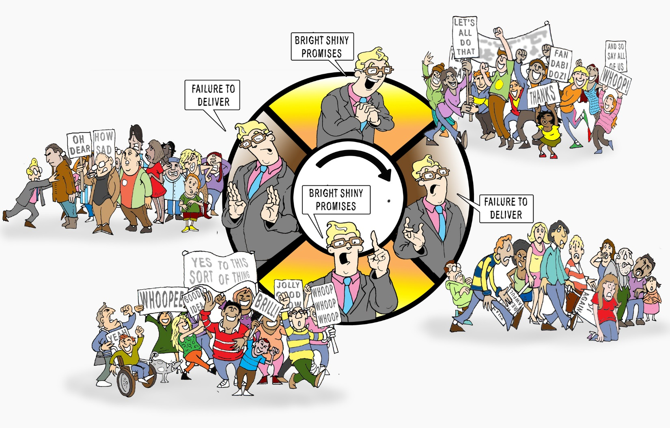

Version 1.0 October 2020.
Let us know what you think – contact@climateemergencymanchester.net

www.climateemergencymanchester.net
Contents
Executive Summary 3
Introduction 4
What you have to do 4
What IS scrutiny? 5
How scrutiny is SUPPOSED to work 6
The six scrutiny committees 10
Subgroups and task and finish groups - the long grass? 13
The mechanics of the meetings 13
Kinds of behaviours you will see at scrutiny in general 17
Before the meeting 17
On the day 18
Practical information 19
Why is scrutiny in Manchester not great, in general and specific 20
Overwhelming numbers of one party 20
Desire/willingness to silo climate 20
Councilors are NOT climate experts 20
Councilors are super busy on other scrutiny and with other work 20
What is to be done? 21
General 21
Specific 22
For each scrutiny week 23
Before 23
During 23
After 23
Active Citizenship Toolkit elements 24

Disclaimers
CEM provides this information in good faith. No responsibility can be taken for any failure to launch an ecological revolution.
If you spot things that weren’t as clear as they could have been, please let us know, for the sequel, due in May 2021 (unless the Mad Max hellscape arrives a couple of years ahead of schedule. In that case, well, the Cocker Protocol, my friends, the Cocker Protocol... (see here).

Fantastic cover cartoon by Marc Roberts – smarcroberts@gmail.com

Executive Summary
This handbook will help you and your colleagues (because you’re not trying to do this alone, right?) understand how local government is supposed to keep tabs on itself and make sure others can also keep tabs on it. That is, after all, a key way democracy is different from dictatorship and authoritarianism.

So, it will tell you about the six existing “scrutiny committees” of Manchester City Council, how they work, why they are not fit for purpose (this is not down to the personalities of chairs or members of committees - the reasons for failure are far more structural than that.

On the question of what is to be done/who will bell the cat, it then lists some of the skills, knowledge and relationships you will need to help keep tabs on the council. (To do this it uses the language of an “Active Citizenship Toolkit).

The hour is late, and it is likely that the actions we take will not be adequate to the scale of the challenges we face. Neither of these gives anyone permission to quit, or to do less than they absolutely can. Such are the privileges of being alive in the 21st century.

Climate Emergency Manchester basic facts
- Was founded in March 2019. In a nutshell - it is a bunch of friends/allies who live in Manchester (and in one sad case Hazel Grove) who think that this city should have done MUCH more about climate change - that the City Council has sat on its thumb for a decade while spaffing some money against the wall on stab-vest organisations like the Manchester Climate Change “Agency”.
- Is not affiliated to any political party, or any environmental group
- Wants to see emergency action on climate change that doesn’t punish the poor for being poor

Still, in the absence of a functioning time machine, we are where - and when - we are.
So, CEM tries to point out that an emergency means you start doing things differently. NOW. And CEM is suggesting a series of things the Council could do differently. All the while knowing that the Council will not do anything differently unless citizens - a lot of them - from all walks of life, from all 32 wards - drag it kicking, screaming and resisting, every step of the way.
CEM is up for being part of that effort, and hopes that you are too. If not, well, have a nice Anthropocene.

Introduction

What is “scrutiny”? In other words, what is it, who is doing it? how? How could it be done? By who? The sorts of questions you probably haven’t lain awake thinking about, because you’re a normal human being and you vote for smart people to take care of this for you.

This handbook aims to answer those questions, and more. By the end of it you should - if everything goes according to plan (and no battle plan ever survives contact with the enemy) have a much better grasp on what is and is not happening in local government in Manchester, and what needs to be done.
Done by who?
You, that’s who. Ain’t nobody else gonna save you.

It starts by explaining what ‘scrutiny’ is, where it comes from. It then moves on to how Manchester City Council is structured.

Finally, there are a series of recommendations. Experience suggests that Executive members - even if they read this - will not act on recommendations, no matter how sensible or emollient the couching Why would they? They have the power, and they quite like not being scrutinised.

What you have to do
First thing is to be sceptical, obvs. Check out what we’ve written
If you want to change things in this city, you can’t do it alone. You can get involved with CEM, or with another group if you can find one as cool and fun as us.
Then, be ready for a slog. You can’t do it on your own or quickly: this is a marathon, not a sprint.

What IS scrutiny?
A dictator doesn’t have to take any shit from anyone. Nobody gets to second-guess them, or carp about what they do or don’t do.

While some people fantasise about a nanny or Big Daddy who will come and”fix everything,” in reality, dictatorships are pretty inefficient. For one thing, people are (over)promoted not for competence, but for loyalty and sycophancy. And since nobody wants to tell the people above them bad news, mistakes and warnings get buried/ignored. (There’s an old saying that you can judge the health of an organisation by quickly how bad news travels up).

For a while now (a few centuries), dictators have had to listen to folks hollaback. That might be via riots (a crude way of sending a message) or via political parties, social movements etc. (read this). Then, in the current era, on individual policies you end up with an ecosystem of think tanks, pressure groups advisory panels etc
In democracies (and the UK is de jure a kind of democracy, if not particularly so de facto), there is this neat thing called the “separation of powers.”
This is - supposed - to stop individual leaders from going full Stalin (to paraphrase that scene in the problematic movie Tropic Thunder, “never go full Stalin”).

One part of this separation of powers (the acronym is instructive) is scrutiny by other politicians. This means that while there is an executive (in the UK the Prime Minister and his cabinet and junior ministers) at the same time there are OTHER politicians whose job it is to make sure policies are getting implemented, money is being spent wisely, lessons are being learned etc

These politicians come from other political parties, because across the country different constituencies will reliably elect someone from one party, meaning no single party ever has totally (70 percent and upwards) of the seats in the parliament.

However, this is not always the case at local government level. In Manchester, the Labour Party holds 93 of the 96 council seats.

Beyond these opposition members of parliament,and select committees and other committees, you also have have a whole bunch of “independent” watchdog outfits - e.g. the National Audit Office - whose job it is to ask questions and write reports which get a half-day run on what is left of the BBC before some celebrity gets in a spat and everyone goes full Moral Panic. Thus are late capitalist countries ‘governed’. But I digress...

The problem is that, for various reasons, over the last several decades - and this is across many countries, and regardless of who is in charge - the Executive has been gobbling up more and more power, and reducing the legislature to the role of a rubber stamp, or mushrooms - “kept in the dark and fed on bullshit.”

Every so often there will be a big enough scandal that there’s a Royal Commission or some independent outfit is set up, but after a few years the original leader of that is replaced by a ‘reliable’ person (e.g. a flunkey, someone with particular ambitions, or someone on whom the Executive has some juicy dirt) and normal service resumes.

One blip in this has been the Freedom of Information Act 2000, which Tony Blair (Prime Minister from 1997 to 2007) regards as his greatest mistake (several hundred thousand dead Iraqis may have a different opinion, but there you are.)

And scrutiny REALLY breaks down when one party has almost all the seats in a parliament. It means awkward issues can be perpetually shunted to one side, especially if the media and civil society are not up for a serious push back. To repeat, in Manchester, Labour hold 93 of the 96 council seats.

How scrutiny is SUPPOSED to work

Westminster system
In a Westminster system the Executive (the people in charge of the key posts within the Government) is supposed to be “in charge”, but not do whatever the hell it likes.
There are committees (often called “Select Committees” which in theory have the power to force Ministers and officials to turn up to answer questions. It CAN, with luck, force the Executive to behave itself, because newspapers and media cover the select committees and explain how this or that mistake/set of mistakes have been made. With luck, the Government both says it will do better and means it (by finding some competent people, and adequately resourcing the effort, whatever it might be.)
We are less and less lucky, as time goes on.

There are of course other systems of government, but this is - allegedly - the one we have. Others set much less store on an active, engaged and gobby citizenry.

Role of mass media (fourth estate)
The scrutiny process also depends on journalists ferreting out stories, or disgruntled politicians and civil servants leaking things to journalists once the internal ways of trying to stop Bad Things happening have not worked.

But the business model for the mass media has been breaking for a long time (newspapers in long-term decline - the cover price doesn’t meet the running costs, so requires advertising. But with the internet, and the ability to target advertising more specifically at key audiences, advertising is moving online, so newspapers are losing key sources of revenue. So they have fewer journalists, and are more reliant on “official” sources, including those who need scrutiny. And because the paper is then full of press releases - government and corporate spin, mostly - fewer people buy the paper, leading to losses and more journalists losing their jobs… This is the case nationally, and even more so locally.

Whistleblowers, (aka “Lamplighters”)
What is politics?…
Little Johnny came home from school one day and said to his father, "Dad, what can you tell me about politics? I have to learn about it for school tomorrow."
The father thought some and said, "Okay, son, the best way I can describe politics is to use an analogy. Let's say that I'm capitalism because I'm the breadwinner. Your mother will be government because she controls everything, our au pair will be the working class because she works for us, you will be the people because you answer to us, and your baby brother will be the future. Does that help any?"
Little Johnny said, "Well, Dad, I don't know, but I'll think about what you said."
Later that night, after everyone had gone to bed, Johnny was woken up by his brother's crying. Upon further investigation, he found a dirty diaper. So, he went down the hall to his parent's bedroom and found his father's side of the bed empty and his mother wouldn't wake up. Then he saw a light on in the guest room down the hall, and when he reached the door, he saw through the crack that his father was in bed with the au pair.
Because he couldn't do anything else, he turned and went back to bed.
The next morning, he said to his father at the breakfast table, "Dad, I think I understand politics much better now."
"Excellent, my boy," he answered, "What have you learned?"
Little Johnny thought for a minute and said, "I learned that capitalism is screwing the working class, while the government is sound asleep ignoring the people, and the future's full of shit.

Occasionally something will be so godawful that someone in the know will leak the information to a newspaper/TV programme. Famous whistleblowers include - Clive Ponting [UK civil servant, leaked on the Falklands], Daniel Ellsberg [US military guy, leaked the ‘Pentagon Papers’], Katharine Gunn [ex-GCHQ linguist leaked about attack on Iraq], Serpico [New York cop, leaked on corruption].
(“Serpico cringed the first time he heard himself referred to as a whistleblower, and years later, he still does not like the term. It sounds demeaning for such a noble cause. Serpico feels Lamplighter is a term that sheds light on corruption, injustice, ineptitude, and abuse of power. Paul Revere was a lamplighter, and Serpico prefers that term.” Source]

But far too often, nobody leaks, because they (quite sensibly) fear retribution.

Also engaged citizenry (fifth estate)
And, in theory, there is supposed to be an engaged citizenry, which knows what is going on, and decides to kick up a stink when things Go Wrong. Yeah, right.

There was never a golden age for engaged citizenry (well, not recently). Basically, people’s wages and security of employment have gone down as the neoliberal project has worked to ensure profits go up. Alongside this, the organisations that used to be useful intermediaries (always imperfect ones, of course), such as unions, churches, campaigning groups/NGOs have withered under relentless assault. The ones that are still standing are a shadow of their former selves. The very idea of collective action, to challenge an elite, is under attack.

In addition, the UK is massively centralised. Local government is not prioritised / not taught.

So, scrutiny just doesn’t get done.

Monitory democracy (John Keane)
Monitory democracy is a phase of democracy characterised by instruments of public monitoring and scrutinising of government power. The theory was coined by Australian Professor John Keane. As per wikipedia -
Monitory institutions refer to 'watch-dog' and 'guide-dog' bodies which subject governments to a public mechanism of checks and balances. Under the theory of monitory democracy these institutions extend the notions of representative democracy to "enfranchise many more citizens voices"^{[2]} in the political process. The ability to publicly monitor government power enabled through these institutions has the effect of changing the political and geographic dynamics of existing representative democracies.
“Napoleon, with the dogs following him, now mounted on to the raised portion of the floor where Major had previously stood to deliver his speech. He announced that from now on the Sunday-morning Meetings would come to an end. They were unnecessary, he said, and wasted time. In future all questions relating to the working of the farm would be settled by a special committee of pigs, presided over by himself. These would meet in private and afterwards communicate their decisions to the others. The animals would still assemble on Sunday mornings to salute the flag, sing Beasts of England, and receive their orders for the week; but there would be no more debates.
In spite of the shock that Snowball's expulsion had given them, the animals were dismayed by this announcement. Several of them would have protested if they could have found the right arguments. Even Boxer was vaguely troubled. He set his ears back, shook his forelock several times, and tried hard to marshal his thoughts; but in the end he could not think of anything to say. Some of the pigs themselves, however, were more articulate. Four young porkers in the front row uttered shrill squeals of disapproval, and all four of them sprang to their feet and began speaking at once. But suddenly the dogs sitting round Napoleon let out deep, menacing growls, and the pigs fell silent and sat down again. Then the sheep broke out into a tremendous bleating of "Four legs good, two legs bad!" which went on for nearly a quarter of an hour and put an end to any chance of discussion.”
Chapter 5, Animal Farm, George Orwell

According to Keane, monitory democracy adds to the democratic nature of political representation as it changes the notion from "'one person, one vote, one representative'” and instead embodies the principles of "one person, many interests, many voices, multiple votes, multiple representatives.

How scrutiny has worked/does work in Manchester
NB to be super clear - the officers who support the running of the scrutiny system are not responsible for the behaviour of elected members and other officers “within” the scrutiny meetings. They have always behaved with exemplary professionalism when responding to questions from CEM. Our very very strong advice to campaigners is to remember the distinction between officers who are tasked with making the television set run, and those who are performing on the terrible soap opera/comedy-drama that is scrutiny itself.

History and Present
Maybe one day we will write about the shift in the 1980s from the committee system of decision making to the Executive model in the mid-late 1980s, but don’t go holding your breath.
For 30 plus years now we have had a model where while there are lots of councilors (96 at present), it’s only a small number of them who are making the decisions, the “Executive”, which fluctuates in size but is usually 8 to 10 councilors.

One particular thing to understand about Manchester is just how unusual it is - the same party in charge for so long, never in a position where another party had more than 2/5ths of the seats (and even then only briefly), with one leader for almost 25 years. This creates a certain culture, a certain set of assumptions about how things can and should be done.

The Executive and the “Joint Consultative” Panel
The Executive meets around 10 times a year (the meeting itself is a rubber stamp.)
All 10 Executive members are Labour councilors. The Leader and two Deputy Leader places are ‘permanent’. The Leader (since 1996 it’s been Richard Leese) is appointed by the full Council. The Leader then, in turn, appoints both their deputies and the other 7 executive posts (but there is a vote about these posts within the Labour Group).
The Executive has responsibility for a number of portfolios that are distributed amongst its members. These include Children Services, Finance & Human Resources, Adult Services, Schools, Culture & Leisure, Neighbourhoods, Housing & Regeneration and Environment, Planning & Transport. The Leader of the Council chairs the meetings of the Executive.
The 7 non-permanent posts can be held for up to four years (Executive Members tend to get annually re-elected, unchallenged, by their Labour colleagues). However, after four years in one portfolio, they come off the Executive for at least one year and, if they want to go back on, it cannot be in the same portfolio.

Once a report makes it as far as the Executive, approval tends to be a rubber-stamping exercise as no Executive Member likes to interfere with another Executive’s portfolio, and certainly not in public. This would be considered an extreme act of disloyalty/breach of Labour Party unity.

Members of the public can attend Executive meetings but can only speak on an item if they have gotten permission from the chair beforehand.
There is also a Consultative Panel that has a standing invitation to attend these meetings. All but one of the Consultative Panel members are Labour. The sole opposition voice is Cllr John Leech (Liberal Democrat, Didsbury West).

The six scrutiny committees

The role of a Scrutiny Committee is to help develop policies and scrutinise the Council’s work and decision making. They do not have decision making powers themselves. There are 6 Scrutiny Committees. Below we give some details about each one, mostly lifted from the Council’s own website.

Children and Young People
https://democracy.manchester.gov.uk/mgCommitteeDetails.aspx?ID=145

Remit: The Children and Young People Scrutiny Committee challenges the Council and other public services to make sure that they give young people in Manchester every chance to live happy, fulfilling and successful lives.
Areas of interest include education, looked after children, social care for children, provision for under 5's, disabled children, special educational needs and activities and facilities for young people.
The Committee also looks closely at the work of the Directorate for Children’s and Families and reviews how the services it delivers meets residents’ needs.

Communities and Equalities
https://democracy.manchester.gov.uk/mgCommitteeDetails.aspx?ID=149

Remit: The Communities and Equalities Scrutiny Committee challenges public services to work together to make Manchester a safe city. The Committee tests how the Council and its partners are making sure their services are equally easy for all Manchester's diverse residents to access. The Committee have discussions with these organisations and use experiences of representing residents from a wide range of backgrounds to recommend to them how they can ensure their services meet the needs of all Manchester residents.
Areas of interest include cohesion, equality and inclusion, services for older people, advice services, young offenders, domestic violence, crime and policing, the voluntary sector, culture, libraries and theatres, and leisure and sport.

Economy

Remit: “Economy, perhaps even more than the other Committees, often relies on the work of other bodies (GMCA, TfGM, government agencies) to inform our reports, and this can impact on when we are able to scrutinize things. Put simply, we often have delays to reports that are outside MCC's control. This means there is sometimes a bit of juggling to be done with agendas in order to scrutinize things effectively and in a timely way. “

Health
https://democracy.manchester.gov.uk/mgCommitteeDetails.aspx?ID=142

Remit: The Health Scrutiny Committee looks at how the Council and its partners in the NHS deliver health and social care services to improve the health and wellbeing of Manchester residents. The Committee takes a broad view of the health and social care services that are commissioned and provided by both the NHS and the Council so that it can make recommendations about how they can improve these services.
Areas of interest include social care for adults, health inequalities, health services, the protection and safeguarding of adults in receipt of health and social care services, mental health and wellbeing, experiences and outcomes for patients, public health and healthy living.

Neighbourhoods “and Environment”
https://democracy.manchester.gov.uk/mgCommitteeDetails.aspx?ID=148

Remit: The Neighbourhoods and Environment Scrutiny Committee deals with many of the Council's services which are most visible to residents - housing, highways, the street environment, waste and recycling - and also monitors the council's planning and environmental policies, including carbon reduction plans and climate change strategy.
The Committee also looks closely at the work of the Growths and Neighbourhoods Directorate and examines how the services it delivers meet resident’s needs and expectations.

In 2014 campaigners (including the author of this handbook) won a battle - quarterly reports on progress on the council’s climate activities would be brought to the committee. In 2018 these quarterly carbon reports were abolished by the current Executive member for the environment.
They have now been reinstated*… but they remain confusing, with shifting baselines, many items not reported.
(Well, they have been promised. But they are not there in the October 2020 NESC agenda pack, and the chair of the committee has asked the Exec Member, with no answer yet. So maybe it will be yet another broken promise…)

Resources and Governance
https://democracy.manchester.gov.uk/mgCommitteeDetails.aspx?ID=137

Remit: The Resources and Governance Scrutiny Committee has two broad roles. One is to keep a close eye on the Council's finances and the other is to make sure that elected Councilors can voice residents’ concerns in an effective way to different public services, such as the Council, NHS, Police and Fire. The Committee holds discussions with these organisations and use local knowledge of Manchester to recommend to them how they can ensure their services meet the needs of residents. Areas of interest include finances, Council buildings, staffing, corporate and partnership governance as well as Council tax and benefits administration.

For all of these, spotters’ cards will be available on the Climate Emergency Manchester website as soon as the new committees are confirmed in mid-May 2021.

The missing seventh committee
A seventh committee dedicated to climate policy and the implementation of climate policy is urgently required.
Right now, because the NESC agenda is so over-packed, climate gets discussed maybe 3 or at most 4 times a year, usually in very vague and incomplete ways. Sign and share the petition!

Scandalously, the October 2020 meeting of Neighbourhoods and Environment doesn’t have any climate change item, despite the city having burnt through a quarter of its climate budget in the last two years.

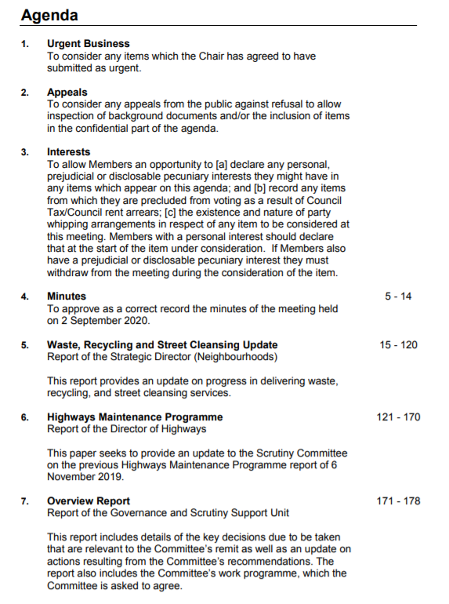

Subgroups and task and finish groups - the long grass?

In addition, there are also usually a handful of scrutiny subgroups which are periodically set up to undertake more detailed reviews of specific areas. These are made up of a smaller number of councilors, usually from a single, or possibly two (or even more) scrutiny committees.
Subgroups can only make recommendations to Scrutiny Committees. They also usually have a limited life span (usually four meetings). Their deliberations are NOT live-streamed, nor archived on the City Council’s website. However, the subgroups are filmed and Climate Emergency Manchester has been able to acquire this via a FOIA.

Subgroups may seem like progress, and sometimes they can be. Or they can be where good ideas and activist energy go to die.

Oh, and the Climate Subgroup, that hasn’t met since January 2020.

The mechanics of the meetings

Before
The agenda for each of the upcoming meetings is available online a week before the meeting (this is a legal requirement).
That does not mean that all the papers to be discussed will appear at the same time. Quite often the fateful words “report to follow” appear. This can mean that members of a committee and the public have even less time to read a report and figure out what is not being reported, or what is being spun.

Before the ‘rona (i.e. a million years ago) there were also paper copies on the racks at the end of the curved corridor of the ground floor of the Town Hall Extension. As you head from the St Peter’s Square end through towards the Mount St end, before you go down the step into the foyer where the lifts are, on the right hand side you will see wooden racks with copies of the following weeks’ meetings papers (not just for Scrutiny, also for Council, Executive, the regulatory committees)

Our free advice would be
- Download the agenda and then do a keyword search on the issues you are interested in. That can be quite revealing
- Skim the introductions to each report, but take them with a pinch/handful of salt. Do not expect that it will be particularly accurate.
- Do not put pressure on yourself as an individual to be up to speed on all the agenda items on a single committee, let alone across all of them. That’s what teams are for…
- Talk to someone else who also cared about the same issues as you: what do they make of this?

One good long-term aim is to become at least a practitioner, even maybe an expert at the Active Citizenship Toolkit element “reading a council document.” Once you’re a practitioner you should be helping anyone else who wants to get better at this - in the process of doing that you will more deeply embed your own knowledge.

On the day
The webcast will start when the webcast starts. Grab a mug.
If we ever get back to something like “real life”, you can be in the room where the meetings happen beforehand. If/when that day comes, CEM will return to its practice of organising pre-meetings nearby.
Officers and elected members usually come in a few minutes before the scheduled start time - the Labour councilors (most of them) will have a “pre-meeting” where they basically hash out what will get asked. Not that this rendered the whole thing relatively farcical or anything. No, no, not at all.

The meetings start on time (some chairs more stickler for this than others)

The first items are usually super quick

Urgent business  - e.g. coronavirus outbreaks that need to be reported on and discussed  Appeals  “Hey, we think x is unfair”  Declarations of interest  “My husband owns a tonne of stock in the company mentioned in the report on buying lots of body bags for the coming deathsquadification of civil society, so I’ll have to recuse myself on that one. Someone text me and I’ll come back in, while also booking myself a makeover at a top-whack beauty salon.”  Minutes of previous meeting  USUALLY not a problem - occasionally you get someone saying “ah, Chair, I wasn’t actually in the room for that item” or “I asked that my particular concern about x be minuted. It hasn’t been, and I’d like it for the record.” | 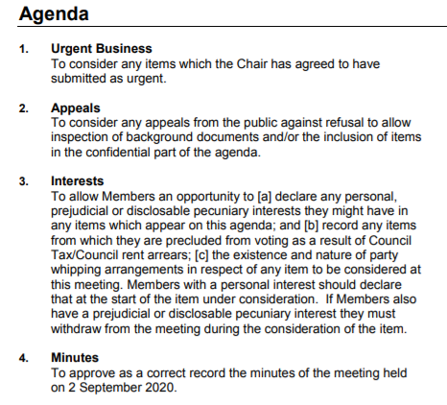

Substantive items
There are usually 3 or 4 significant items on the agenda. That should work out at about 20 to 30 minutes, BUT individual items can run longer (meaning either the meeting over-runs, or other items get squashed or shunted onto the next meeting)
For each item there should be a report - should be released a week in advance, and almost always written in Council-ese with whatever buzzwords are popular at the minute.

The report is then introduced either by the responsible Executive Member and/or the officer who wrote it/who is in charge. Some chairs say “we will take the report as read” so there is more time for questions.
Other chairs allow the Exec member and/or officer to repeat what has been said in the report (why? Oh so the people can remind themselves they exist by hearing their own voices, I guess). The most comedy comes when some of the Exec Members say things like “Well, I won’t say anything, except very quickly this…” - and then proceed to serve up five minutes plus of pure word salad. Not because they are so clever as to be ‘talking out the clock’ but just because… oh, my god…

Anyway, you then have a period for councilors to ask questions.
Some chairs go round the room on the basis of where folks are sitting.
Most chairs limit a councilor to one or two questions at a time, then let them come back if there is time after all the other members of the committee have had a turn.
Most councilors will do the ritual “thanks to the officers for this wonderful report” thing, even if that’s not what they actually think.
Some (not enough) will ask short, specific questions. Others will have a preamble that goes on for minutes, and adds nothing, before coming out with something vague and virtue-signally. “Like being savaged by a dead sheep” as someone once said...

What happens next depends on what the report was “for”. But ultimately, even if a committee has been asked to recommend a report, or sign off on some action, it doesn’t matter if they refuse to do so or not, because the Executive Member may just decide to do whatever is convenient. That’s not how democracy SHOULD work, but it is how the hollow show currently does…

Overview report
This is worth looking at, because it tells you what is (supposed to be) coming up

Duration of a scrutiny committee meeting
There is no hard and fast rule that says a meeting has to finish after two hours. Most do, because councilors - most of whom have other jobs - have places to be... And most everyone is losing the will to live..

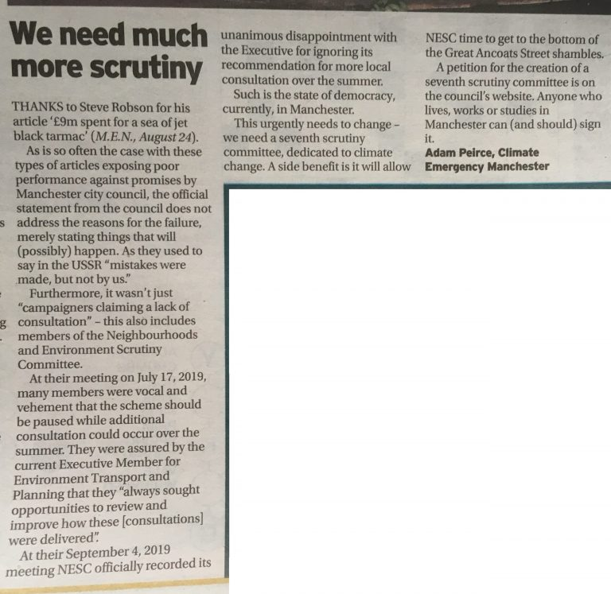
Letter published in the Manchester Evening News, 27 August 2020

Kinds of behaviours you will see at scrutiny in general

If you have never been to a scrutiny committee you are in for a bit of a shock… These can be horrifying and debilitating spectacles. But on a good day, an elected representative can get some actual answers…

Before the meeting
From officers and executive members

Produce dense reports which hide/fail to report awkward facts
- Re-write history to gloss over things that didn’t happen that should have. (You see this ALL THE TIME with regards to climate change)
- Shift the baseline so you always look better

This means that people (councilors and other citizens) have to wade through treacle, repeatedly.

It is crucial to understand - and never ever forget - that, from the point of view of the officers and the Executive Members, the point of a report is to make everything look mostly/entirely okay… The report is NOT to highlight problems/ask for help, or assist overworked councilors understand what is going wrong. That would give ammunition to potential enemies - never mind the opposition (it is tiny, largely powerless- the real enemies are in the party/in the bureaucracy). Reports are exercises in arse -covering, not in a free and frank assessment of what is actually going on. The sooner you realise that, the less confused and more effective you will be.

Release the reports at the last possible moment
e.g. On the Friday, or the even the Monday before they are to be discussed, reducing the amount of time councilors have to read, to skim, to find what is missing, to ask advice
Reduce time citizens have

Move items to future agendas if it is not politically convenient
Just keep bouncing the item, adding frustration. Slot it in to an otherwise packed agenda, to minimise available time.

Simply stop producing reports which would contain awkward information
For example, in May 2018 the Executive Member for the Environment simply stopped producing quarterly carbon reports (These have allegedly now been reinstated.)

Bully chairs etc
If a chair proves insufficiently pliant and obedient, well, Executive Members may throw a tantie because they cannot cope with scrutiny, and complain that the Chair is (checks notes) … doing their job, and threaten to drag them through the formal complaints process.

Make it clear to outspoken councilors that they are risking their promotion prospects by speaking out of turn publicly. In a council where 93 of the councilors belong to one party, this has really severe consequences. The beauty of it is that it happens behind closed doors.

On the day

From Executive Members and Officers

Long answers to short questions (aka ‘talking out the clock’ aka waffling)
They waffle. They use 500 words when 50 would do. In part because they are so stupid and insecure that they are not quite sure if they exist or they matter unless they are hearing themselves drone on. but also because it means there’s less time for actual scrutiny. Pity that, eh?

Stonewalling
Refuse to answer a question, play dumb (not hard for some of them).
Say it is none of anyone’s business
Say that “the decision has been made” etc

Changing the subject
Answering a different question, one you wish you’d been asked.

Promising answers at a later date (may or may not be provided)
“I’ll get back to you.” And if you believe that, I have a bridge in Sydney to sell you.

From councilors
Actual Scrutiny (gasp!)
Persistent, precise, patient. Rare, but not unheard of. Of the scrutiny committees I’ve seen, Resources and Governance seems the best, at the moment at least. There are forensic questions and and willingness to challenge prevailing orthodoxies. This may in part be because it has responsibility for matters to do with the money…

Chest-beating and grandstanding
People trying to signal their virtue. Especially if there is a local election coming and they need to be able to convince voters they are fighting the good fight.
Metoo-ism
Not experts on the topics presented and needing to hear their own voices to reassure themselves that they exist.

Lost (in the weeds)
Sometimes councilors are unable to cope with the big picture, or knowing it will piss off the bosses, so instead remain silent or else focus on something super small/manageable. You used to get this a LOT with the climate change issue, where councilors would shy away from climate change and focus instead on LED lighting for lampposts, and dog shit.

From members of the public
Speeches
Members of the public can attend meetings (except for the bits they might get excluded for)

Specific questions (if allowed)
Always good to watch the officers squirm. They never actually answer of course. THat’s what FOIAs are for though...

Banging head against wall/resisting urge to kill selves
You will see a lot of this. Also, olympic level eye-rolling, sighing and guffawing with incredulity

Practical information
How are chairs appointed?
Voted by the relevant parties. To get a scrutiny chair, your party really needs about 1/6th of the 96 seats (16). So, right now, only one party is relevant.
How is membership of the scrutiny committee determined?
People put themselves forward. If there are too many wanting onto one committee, there’s a celebrity death match (actual facts may vary, always read the label).

How usual is it for membership to change during course of a year (and reasons)?
Not that common, but nor is it unheard of.

What are the behaviours for which a scrutiny committee member can be kicked off?
Non-attendance
Not declaring a conflict of interest
Bullying etc
But merely turning up and sitting there, schtum, no - that’s okay.

Do members of the public have the right to speak?
Nope

What else can they do?
Look on in horror.
Join with others to do effective scrutiny (thus this hanbook).

Why is scrutiny in Manchester not great, in general and specific
Because reasons
Blaming individual councilors for being lazy, stupid, cowardly etc is not particularly helpful (while it may explain one -off instances, but lacks wider explanatory power).

Overwhelming numbers of one party
The Westminster System really struggles when one party has the overwhelming majority of seats.
Individual councilors may be afraid to rock the boat, afraid to be smeared as disloyal to the Party, especially if they are ambitious for an Executive position themselves
Many Executive members have significant (social/political) power within the Party
Officers can take revenge…

Desire/willingness to silo climate
What do all of us do when confronted with a messy or complex problem? We find someone else’s lap to dump it in, is what we do. Who wants to grasp a nettle which might turn out to be a fricking bomb? So, a while back Health Scrutiny refused to look at climate...

Councilors are NOT climate experts
Councilors are not experts on anything much, unless their day job made them so. They tend to be concerned and/or ambitious citizens, who have decided to devote a lot of time and energy to… being a councilor. There are enormous amounts of case work (citizens coming to them for help(

Councilors are super busy on other scrutiny and with other work
Councilors do not do this as a full-time job. They have jobs, families, hobbies, party duties etc.

What is to be done?

If you REALLY wanted to fix scrutiny then you’d need
- Some kind of proportional representation at a local level
- Find a new business model for local media
- NGOs and civil society organisations who understood the word “co-optation”
- Teach kids about this stuff in school

None of this is going to happen, and in any case, we do not have time for this. This is an emergency.
Still, let’s grit our loins and gird our teeth and make a few suggestions...

General
Executive and officers
(and this should be demanded and scrutinised of them, since they have zero incentive to do it themselves
Ensure the reports are a bald statement of facts, without spin and bluster.
Forgo the opportunity to make “introductory remarks”
Answer questions concisely and accurately, even (especially) when they come from the opposition.

All reports should
- be run through a ‘plain English’ marker, and given a score
- contain a ‘what has not gone according to plan, why, what we are doing about it.
- Have standardised baselines/give an accurate account of agreed policy (not skating over inconvenient facts
- be released AT LEAST 5 working days in advance of the meeting

Scrutiny committee members
- Ask concise and specific questions
- Refuse to be fobbed off.
CEM
We want to see committee members and members of the public do a better job of exposing the gaps, in the naive and sentimental hope that exposure leads to improvement (it doesn’t but what else have we actually got?).
We commit to the following
- Help train up people to adopt scrutiny committees and sustain their involvement, bringing new people in, without dying of boredom or frustration
- Creating an overview of overview database to track what reports are coming/never arrive,
- Automate way of telling others/explaining to them what is coming
- Spotters cards for each of the committees, updated as required through the course of the year
- Lobbying councilors in between meetings
- Keeping tabs on what is and crucially what is NOT discussed
- Holding pre-meetings where it is appropriate

Countermeasures to the executive/officer behaviour before a scrutiny meeting
- Name the crap behaviour (lateness of papers, low quality) and extract commitments for improvement.
- Write briefing papers and briefing notes to educate yourselves, other citizens and maybe even councilors about what is missing
- Press releases
- Liaison with journalists about the report
- Liaison with chair of the relevant committee
- Ask permission to speak to an item if you have something to say
- Liaise with individual councilors

Countermeasures to the executive/officer behaviour during
- Prepare the councilors who give a damn, explain what will happen
- Liaise with chairs
- Name it at the time (tweeting)
- Name it clearly in your blog post. Say that it is gross, it is unacceptable. Ultimately, for repeat offenders, complain about it through official channels.
Members of the public have to work together, sustain each other’s morale

Specific

Executive and officers
Understand what an emergency means. An emergency means you change behaviour. It means you stop your old behaviours, of hiding everything that is going wrong, of trying to polish the turd, and you are open, honest, and transparent. And this goes against all your experience, all your training, all your incentives. So, yeah, we know, we may as well be trying to teach a dog Swahili
A SEVENTH scrutiny committee
Not by any means a magic bullet. It would be prey to all the pathologies (and probably some more, since new venues are always opportunities/motivations for further innovation by those who would destroy democracy). But it would be a start.

Members of the public
Adopt one of five scrutiny committees. We have NESC covered. We are working on Resources and Governance, your help would be welcome. Economy is next. After that, the other three are kind of of equal interest to us.
At a minimum, familiarise yourself with the remit, the future agenda, the members of it.
Watch the webcast for the last couple, to get a sense of who is a placeholder and who is a player (n.b. this shifts over time)
- Turn up
- Speak at them
- Submit some FoIAs
- Report on them
- Lobby councilors in between times
- Become an expert in one of the topics
- Work with others who turn up, compare notes with other scrutiny committee adopters.

Most of all though, join the campaign for a seventh committee.

For each scrutiny week

Before
Alerting each other to impending items
“Hey x, I know you’re interested in y. Apologies if you already know, but y is being discussed next week [date] etc”

Reading items with a critical eye
See reading council documents

(Optional) Writing briefing papers and notes, alerting journos and councilors
See our briefing papers here. Not gonna lie, the first couple of times is time consuming, but it gets easier..

Contacting councilors with questions
They have email addresses. Most list their mobile numbers.

During
Attending (in real life or online)
It’s important that they see people actually give a damn.

Maintaining the will to live
This can be really hard. See also individual and collective morale maintenance on the activecitizenshiptoolkit.net site.

Telling people about it
Live tweeting, if that is your thing...

After
Reporting at the time (tweeting) and after (blogging)
The sooner the better. Shorter rather than total blow-by-blow

Following up with councilors
Thank the chair if by some miracle you were allowed to speak? Some may say that you shouldn’t do that because it reinforces the whole ridiculous farce that people are not able to speak.
Thank councilors who asked good questions

Following up with officers
“Dear x, you promised councilor x the information. I am writing to you to say that if I am included in the distribution of that, it saves me and you the time of a Freedom of Information Act request. Let me know if you are going to do this. If not, well, FOIA here I come.”

Submitting FOIAs about anything that hasn’t in fact been asked.
You may have asked councilors to ask and they either didn’t get the chance to do so, forgot, or decided not to. That doesn’t have to be the end of the story. Submit a FOIA...

Active Citizenship Toolkit elements
The Active Citizenship Toolkit is a Climate Emergency Manchester project. It aims to make it easier for individuals and groups to figure out what skills, knowledge and relationships they need to achieve their goals, what they have and what the gaps are. It uses the idea of there being different “elements” and each element being something that an individual might have at novice, practitioner, expert or ninja level. For most purposes, practitioner level is sufficient.
The Toolkit is there to help groups figure out their own gaps, but also for them to be able to communicate, using a common language, with other groups, so that mutual learning and support can happen.
You can find out more at activecitizenshiptoolkit.net
For each of the following elements we have descriptor of what it is, level desciptors and an “element overview essay” which outlines the barriers to getting the element at a high level, the consequences of not overcoming those barriers, and some initial unsolicited advice.

Crucial for this
Understanding council structures
Understanding bureaucratic incentives
How to read a council document
Individual Morale Maintenance
Blogging

Understanding council structures
Local authorities are oddly opaque. It’s almost as if they don’t want the voters to know how they function and how they can be influenced. Crazy, huh? Without that knowledge though, success, however defined, is extremely unlikely.
NOVICE | PRACTITIONER | EXPERT | NINJA
You can explain the basic political structure of your local authority, and the different types of role elected councilors fulfill. You have a basic grasp on the officers too, and the decision making process | You have a detailed and historically formed (‘they used to do it like that, now they do it like this) view of the local authority, its culture, the differences between the official set up and what ACTUALLY goes on. | You know the official story, the real story, where the bodies are buried, how the last reorganisation consolidated the power of THIS faction over that one, how the power games are played, who is good at them and what games are on the horizon. | After an hour in your presence, people fundamentally ‘ get it’, now and forever – the scales fall from their eyes, they understand a panel from a subgroup from a regulatory committee from a scrutiny committee, a directorate from a cold steel rail. For all the good it will do them.

See also the brilliant report “Manchester City Council and Climate Change”, February 2020

Understanding bureaucratic incentives
You can’t “win” in bureaucratic games. Sorry, finished that sentence prematurely. You can’t “win in bureaucratic games unless you understand what is motivating the behaviour of the bureaucrats (aka “civil servants”) who are busy trying to ram through all sorts of stupid, albeit dressed up as “green” or “sustainable” – or whatever other meaningless drivel is being pushed at the moment – through the ‘democratic’ processes of your city/state. And unless you understand the tactics, and devise, share, refine countermeasures. If you don’t do this, you’re wasting everyone’s time.
NOVICE | PRACTITIONER | EXPERT | NINJA
You have – and can communicate – a basic understanding of how hierarchical organisations constrain behaviour and reward conformity/obedience/secrecy. You understand and can explain using local examples, the Peter Principle and Pournelle’s Law | You have a more detailed and local understanding of the history of the local organisation you are dealing with – the past and present big fish, where they came from, and what has happened to unlucky/dissident bureaucrats in the past. You can explain ‘evaporative cooling’ and you can explain the different techniques bureaucrats use to gild the turd, and hide from scrutiny | You know the ins and outs of the various departments in the local government bureaucracy, how they fight like cats in a sack, who plays dirty, who leaks what to who and when, which politicians are under the thumb, which ones are on the outer. You know who the likely next bosses and their foibles. Meanwhile, you can confidently and accurately predict the kinds of spin specific Sir Humphreys will use to blameshift in any given scandal. | You can compare and contrast the bureaucratic cultures within your local authority with those of neighbouring/comparable authorities, and trace the lineages/tensions with national cultures. You have written extensively on the reality-distortion fields of bureaucracies in general, and the consequences for effective climate policy (hint, no such thing exists).

Individual morale maintenance

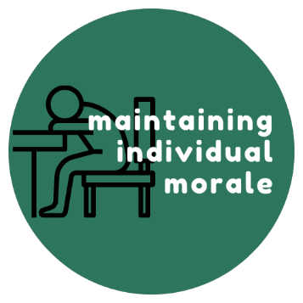
We all want the world to be a Much Better Place sooner rather than later. We want to play our part. BUT… You are doing nobody any favours if you go up like a rocket and down like a stick in your involvement. You need to be able to spot any patterns (and underlying causes) of over-commitment/under-delivery, the likelihood of burnout, its symptoms, how to care for yourself and come out the other side.
NOVICE | PRACTITIONER | EXPERT | NINJA
Able to maintain own equanimity when dealing with a small number of stressful situations, but aware of your own triggers, and have only limited (e.g.) withdrawal ways of dealing with them | Aware of most/all of your own triggers and are able to use a variety of technique to deal with them, maintaining desired level of productivity and functionality, while tackling distressing situations and topics. | Able to consistently model morale maintenance in most situations, keeping perspective and investigating new methods of helping yourself and others. Nothing much can get you down, ever, but that doesn’t mean you don’t care passionately. | The abyss refuses to look into you, because it gets depressed. You are able to maintain morale in the face of multiple interlocking and escalating environmental crises (i.e. the 21st century) and personal car-crashes around broken relationships, friendships, money worries. The Dalai Lama texts you for chillax tips

Reading council reports
Local authority documents are very rarely produced to give an accurate picture of what is going on and could be done. Certainly not the ones for public consumption. They are exercises in bluff, bluster, concealment and brightsiding. Failing to understand that will lead to wasted time and energy.
NOVICE | PRACTITIONER | EXPERT | NINJA
You can read a council document and, with time and prompting, spot where the inconvenient facts are buried (on a footnote on page 17, with a shifted baseline), and what is NOT being talked about. | You are adept at scanning all the documents for a meeting , and retro-engineering them to see what is actually going on, going wrong, and how scrutinisers are being directed towards some issues and assumptions and away from others (whether this is a conscious or unconscious strategy on the part of the report authors). You are able to prioritise a list of questions and comments about these reports. | You can scan many council documents, including on issues you’re not particularly familiar with, and figure out what is actually going on, the hierarchy of what the authors don’t want you to know, don’t want to ask, how they will respond to standard questions and which ones might force them to be straight(ish) with members of a committee. (but not members of the public – that’s a ninja level thing). | The mere suspicion that you will be on the case means that the authors of council documents don’t bother with their usual obfuscation and tosh, knowing they’re gonna get caught anyway. You can point to a documents silences and evasions while catching up on Netfllix shows.

Blogging
Sharing your ideas, opinions, analysis of issues and how you’re processing emotions online in a clear, concise and engaging manner can have quite an impact for both the author and audience. It is there as both a record and can be used to discuss and debate ideas with other interested parties and can usefully complement other forms of communication via social media and meatspace. A decent blog can help amplify your group’s messages, recruit supporters and allies, counter information published by others trying to undermine your work as well as helping getting things out of your head or off your chest.
NOVICE | PRACTITIONER | EXPERT | NINJA
You can draft an article about something that’s recently happened such as a meeting or event that you attended from notes that you’ve previously made, which may include some links to other documents or webpages. It is clear, concise and easy to read using simple conversational language or where technical terms / abbreviations are used they’re explained or expanded upon first use. Someone else will proof it for errors and post it on your behalf. | You can draft up a blog post on more complex or nuanced issues that goes beyond reporting facts or events into your personal opinion on an issue or event. You have developed a voice and writing style that might be more individual to you rather than emulating someone else or keeping it mute. You have learnt how to post blog articles yourself and second opinions are less for proofing and more for constructive input. Posts are still well referenced where required to explain technical terms, abbreviations & acronyms to keep the audience as wide as possible. | You can quickly rustle up blog articles on a wide variety of topics and issues that are of interest to you, the group and your audience. You have a decent dialogue and understanding with a number of your readers and there’s a good back-and-forth between yourself and other bloggers on the posts you write. They’re always high quality, error free, and easy to follow / understand. The arguments you present are compelling and allows your to expand your audience with potential media interest in republishing some of your posts. | You are basically the blogging equivalent to a Pulitzer prize winning journalist. Your blogging is pretty much your profession and you should be getting awards and a wage for your writing. You’ve got a large social media following / audience that regularly amplify your message that creates an ever-expanding bubble of follower. You find pieces being picked up by media outlets and you are being tapped up by media and publishing companies to work for them rather in ever-more lucrative deals than write on some blog anymore.

Nice to have
Research
Freedom of Information Act Requests
Report writing
Live tweeting

Research
Covers a dazzlingly wide range of tasks and professions. For most social movements, research will means gathering a range of detailed, statistical or contextual information on a given issue. Some of this may be widely known to others outside of social movements; some it may be hidden or not in the public domain.
NOVICE | PRACTITIONER | EXPERT | NINJA
Happy to undertake a short research task with a set brief and reasonable time-scale, gathering information in the public domain. The information may be scattered (e.g. Council documents) but does not require any complex methodologies, tools or software. They will be able to present the findings of their research in a way that makes it easy for others to re-use or incorporate into other work. | Confident carrying out complex research tasks with little guidance. Such research may consist of: identifying the sources of information; synthesising a large amount of data; extracting the necessary information from very complex or dense information. The practitioner will be able to apply these skills to a wide range of topics, including those beyond their area of immediate expertise. They are likely to be involved in the analysis of the findings, rather than merely their passing them on for others to interpret. | Concurrently carrying out a range of research tasks, using a wide range of sources and methods. May be able to track down information that is difficult to find or not in the public domain. Able to design feasible research tasks for others and monitor their completion. Quickly able to synthesise the findings and repurpose the research for a range of audiences and purposes. | Can find the answer to anything, at any time. And tell you exactly what it means.

Freedom of Information Act Requests
The Freedom of Information Act (2000) is a key tool in the war against secrecy, complacency and appalling decision-making by policymakers and public bodies in the United Kingdom. Knowing what can be FOIAed, how, and how to avoid the basic mistakes/avoiding giving authorities easy ways not to answer is a crucial skill for active citizens. Not having it condemns you to most definitely blundering around in the dark.
NOVICE | PRACTITIONER | EXPERT | NINJA
Has heard of the Freedom of Information Act (FOIA) and knows that it might help them get useful information for their campaigns or research. Not sure which organisations and agencies are covered by the FOIA legislation. May have submitted an FOIA request but cannot remember where they stored the response email or letter | Has submitted FoIA requests.  Knows how to find out which public agencies and organisations are covered by the FOIA legislation.  Knows that they can submit a FOIA request to organisations anywhere in the UK (not just where they live).  Not always sure why their requests are refused or provides information that isn’t really what they wanted.  Can be put off by responses that tell them that the information is not available or will be charged for. | Has learnt how to focus down their FOIA questions to give little “wriggle” room for refusal or non-answers.  Has successfully obtained useful data from FoIA requests to a range of agencies.  Pays no heed to attempts to discourage their requests.  Has used the Internal Review process when responses initially refused or only partially answered.  Has read (and understands) the reasons why some information is exempted from the FOIA legislation.  Knows when (and how) to use the Environmental Information Regulations 2004 Act (EIR) to prise information out of organisations and companies not covered by the FOI legislation.  Routinely shares their FOIA and EIR responses on public sites. | Knows how to successfully challenge organisations who have refused to provide information that should be available via FOIA or EIR legislation.  Has successfully gone through the whole process of Internal Review and Appeals to the Information Commissioner’s Office (ICO).  Plans ahead for campaign related FOIA / EIR requests taking 20 working days and allows another 20 working days for the Internal Review.  Knows how to use “refusals” to provide information as part of their campaign media work.  Is happy to pass on skills and experience.  Enjoys learning about successful FOIA requests and challenges.  Is overjoyed to receive requests to write FOIA requests at midnight !

Basic Advice about FOIAs
- Keep it specific (fishing expeditions will be unsuccessful)
- Do your own research before you submit
- Have someone check it over before you send it.
- Don’t be afraid to ask for an internal review
- Don’t be afraid to go to the information commissioner if they are playing sillybuggers

Report writing
Not all social movement organisations do or should produce reports. But for those groups who deem them an effective way to further their aims, reports are a vehicle for offering independent analysis, bringing hidden information to light and challenging the dominant narrative. At their best, reports to useful to a wide range of citizens and other groups, and are produced collaboratively with others.
NB – There are many sub-elements to this (research, Freedom of Information Act requests, writing, copy-editing, layout, proof-reading. This is an element, but also part of a compound. It’s best seen as a group -level skill more than an individual one),
NOVICE | PRACTITIONER | EXPERT | NINJA
Happy to turn around or contribute to a short, factually accurate report on an issue where they have good prior expertise and/or with support from others who have produced material on a related topic. | Plans, researches and produces a range of reports, from quick-turn around briefing papers to longer reports which draw on a variety of data sources and methods. The content may be complex, sensitive or be at the edge of their own expertise. Able to work collaboratively with other-groups. Some consideration given to dissemination. | Regularly coordinates a suite of co-produced and well-researched reports. The documents will be readable and well designed, combining novel or complex data with authoritative analysis. Reports will be accompanied by a targeted communications strategy, and will be shared or cited by others. | Produces seminal reports on an impressive arrange of subjects that gain significant traction and make a significant intervention into, nay transform, the policy landscape.

See some of our briefing notes (usually two pages) and briefing papers (we try to keep them to four, but sometimes…)

Live tweeting
The ability to explain what is happening at a meeting, an event, a demonstration, during a TV show, whatever in real time for people who are on Twitter and not present or watching the actual event and explaining to them not only what is going on, but the other things that could and should be, and some context. Not having live tweeting doesn’t mean that your organisation will fall over: it just means you miss an opportunity to get to a wider audience than normal because well-crafted funny tweets do get shared.

Novice | Practitioner | Expert | Ninja
Can with preparation planning and forethought tweet several well- crafted but basic tweets about what is happening with some links to relevant documents, website. | With little time for preparation is able to produce a steady high frequency stream of Funny, insightful, clear tweets that expose not only the banality of what is going on, but missed opportunities and ideas for what could and should be happening. | From a standing start, produce a flood of beautiful, funny, vicious, just this side of libellous tweets, which enable readers to understand what is going on and inspire them to get involved in your campaign | From a standing start able to live tweet long, complex events with a beautiful cadence and tempo.  Knowing what to tweet and what not to bother with sarcasm and bile for all the tweets are so well judged that they can be unrolled as a thread and turned into a blog post virtually at the touch of a button

If you have enjoyed this/found it useful…for the love of Gaia, at the absolute minimum sign the petition and send individual personalised requests to seven (at that is a minimum, please) people you know who could sign it, imploring them to do so.

