“Get a waggle on”: Learning from local authority action in the UK on…

Transport

Climate Emergency Manchester
Lead Author: Adam Peirce
June 2021

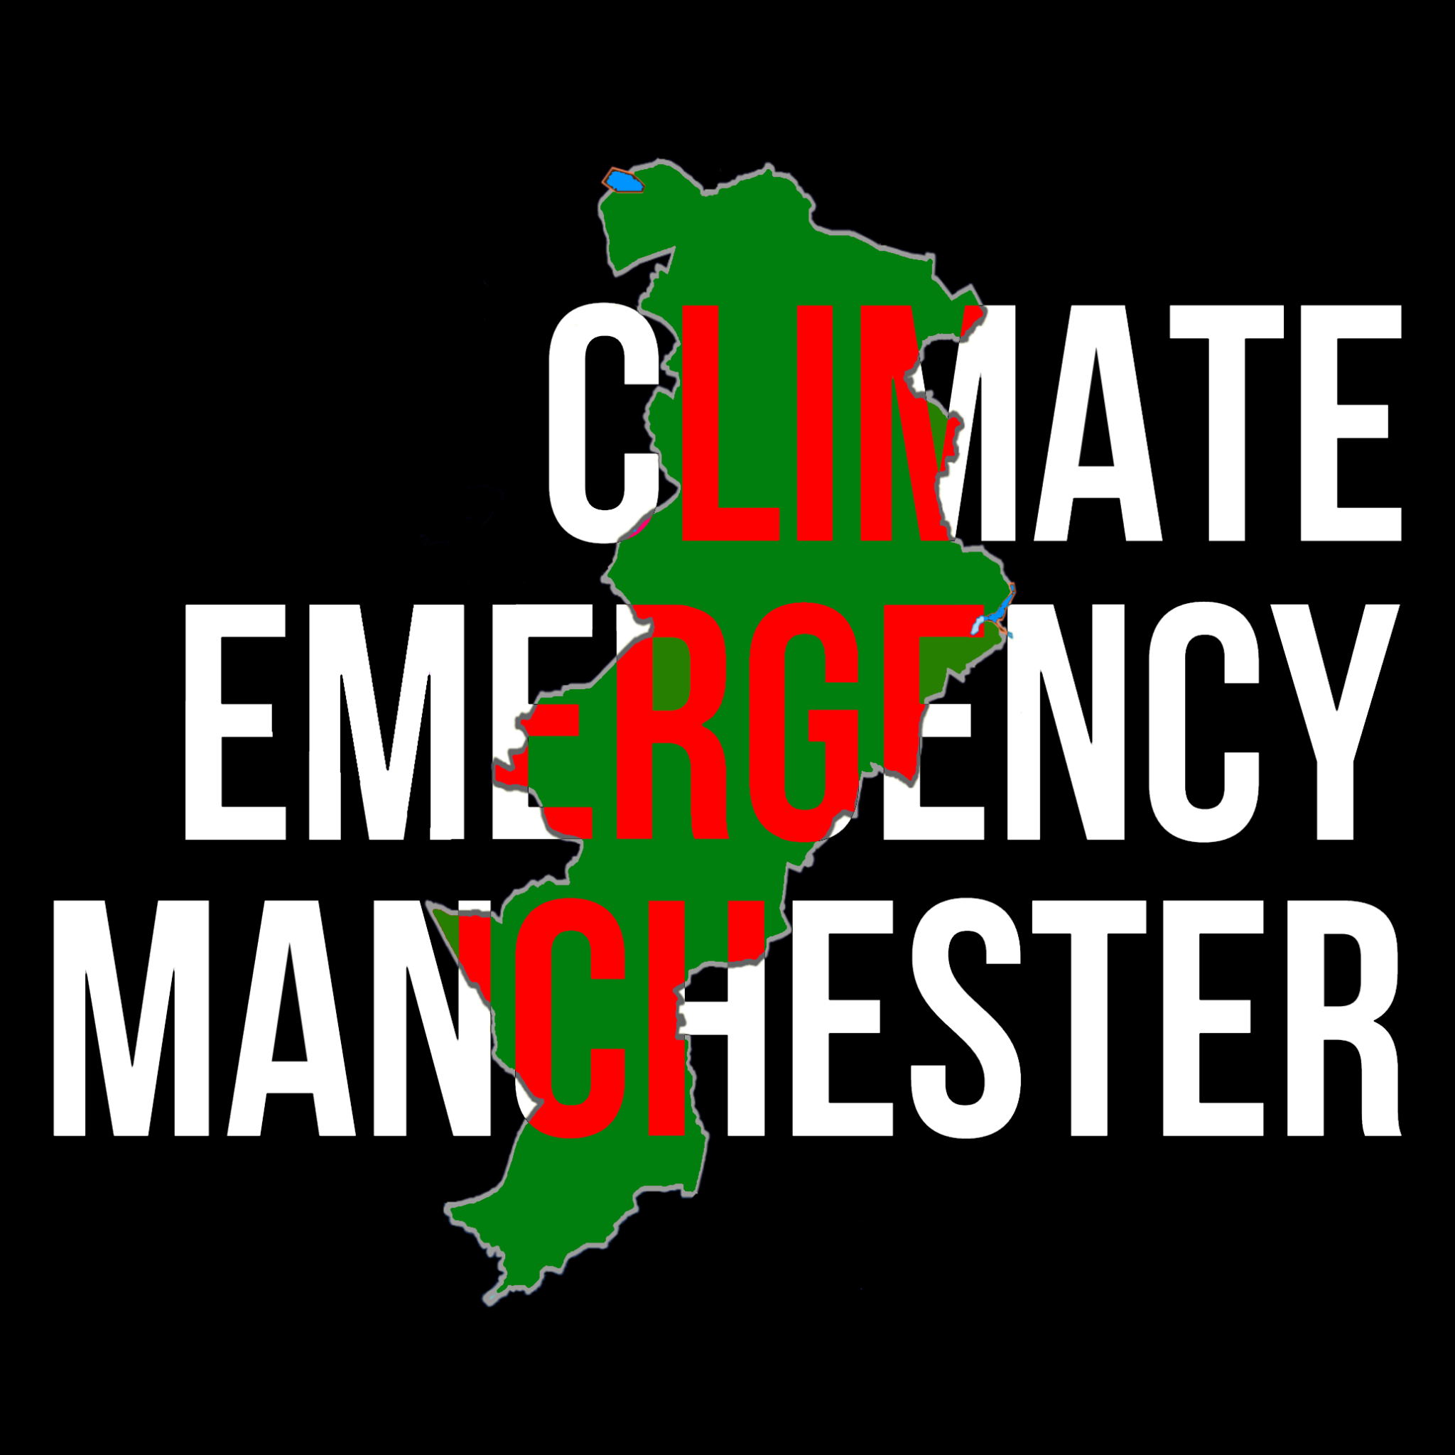

Acknowledgements 3
Executive Summary 3
Introduction 4
Transport - who is doing what? 5
More cycling and walking 5
“Success” stories from other parts of the UK 5
What could be done in Manchester? 6
What needs to be done NOW, by who, to get the ball rolling 6
More journeys on public transport 7
“Success” stories from other parts of the UK 7
What could be done in Manchester? 7
What needs to be done NOW, by who, to get the ball rolling 8
Fewer private car and truck journeys 8
“Success” stories from other parts of the UK 8
What could be done in Manchester? 9
What needs to be done NOW, by who, to get the ball rolling 10
The unheard herd of elephants in the room 10
The Airport 10
Conclusions and next steps 11
Glossary 11
Appendix: Methodology 13
References/Further Reading 14

Acknowledgements
Thanks to Simon Jermy and other supporters of CEM who helped with the research and production of this report.

Executive Summary

This report is an initial snapshot of what is being done well in different parts of the UK on rapid reduction of emissions and increase in effective action around transport. It focuses on just one sector to make the task manageable in the time available, and takes transport first because it is a notoriously hard sector to decarbonise, yet one where there are big ambitions for GM. Transport is also a sector in which there is particular citizen interest, and recent disappointments in Manchester (e.g. pop up cycle lanes). We hope, with supporters and other groups, to consider what is being done well in other areas, like energy. We are also interested in investigating alternative governance structures for climate.

The report has been produced by Climate Emergency Manchester for two audiences:
- Councillors (especially, but not only those who sit on Manchester City Council’s Environment and Climate Change Scrutiny Committee).
- Other interested groups and individuals in Manchester outside the council (e.g. citizens, campaigning groups) in Manchester

Climate Emergency Manchester believes we can (and must) accelerate local action on climate change.

The key recommendations of this report are:

More cycling and walking - Review the decision taken in 2020 not to implement pop-up cycles lanes in the city centre and use new legislation to enforce fines for car parking in mandatory cycle lanes.

More journeys on public transport - Lobby GMCA to create a municipal bus company within Greater Manchester.
Fewer private car and truck journeys - Investigate sites for low cost/intervention park and ride sites and review previous decisions not to introduce a Workplace Parking Levy.

Introduction
Manchester City Council (MCC) set a science-based “carbon budget” in 2018 via support from the Tyndall Centre at University of Manchester. This gave the city 15 million tonnes for the rest of the 21st century. In July 2019 the 96 councillors voted unanimously to declare a climate emergency.

Since then, it has been difficult for citizens and some councillors to identify or understand what effective action MCC, or its arms-length agency (the Manchester Climate Change Agency) has taken to support city-wide emissions reductions or the pathway it has chosen to rapidly reduce carbon emissions. The “partnership” model currently employed may improve dialogue between different organisations (if they are deeply embedded within their communities) and actors within the city. But this has not equated to improved accountability or ambition. Or actual action.

The city is getting through this science-based carbon budget at an alarming rate. In the first two years, a quarter of the carbon budget for the entire 21st century was used up. This failure will be even more evident when the 2020 data are published by UK central government. Although there will be reductions from the COVID lockdown, once lockdown ends, emissions will in all likelihood come roaring back.

The current approach is clearly not working. Policies within the council require climate and wider social equality measures to be far more integrated as well as the ambition of leadership to do this work at scale, pace and with a candid nature similar to that of the COVID response.

This CEM report is in response to a councillor making the following request:

“signpost me to a Local Authority who are making good progress towards reaching their carbon reduction targets. In schools we call it a WAGOLL (What a good one looks like )”

In keeping with Manchester’s love of a bee-theme, we’ve called this report “waggle” - which is a series of movements that worker bees use to show others in their hives good sources of nectar.

We are not saying that policymakers can just copy and paste these examples. Different places have different histories, different capacities. This report does not focus on what Manchester has done well nor compares it against other cities. We looked at Core Cities before here in June 2020.

We are not saying everything listed in here will be a success, but there are some productive policies from other cities / councils that have previously been dismissed by MCC / vetoed by the Leadership in the past. Few dare experiment, because failure is risky. Yet a crucial role for those who lead is to de-risk failure, to encourage innovation and creativity.

Transport - who is doing what?
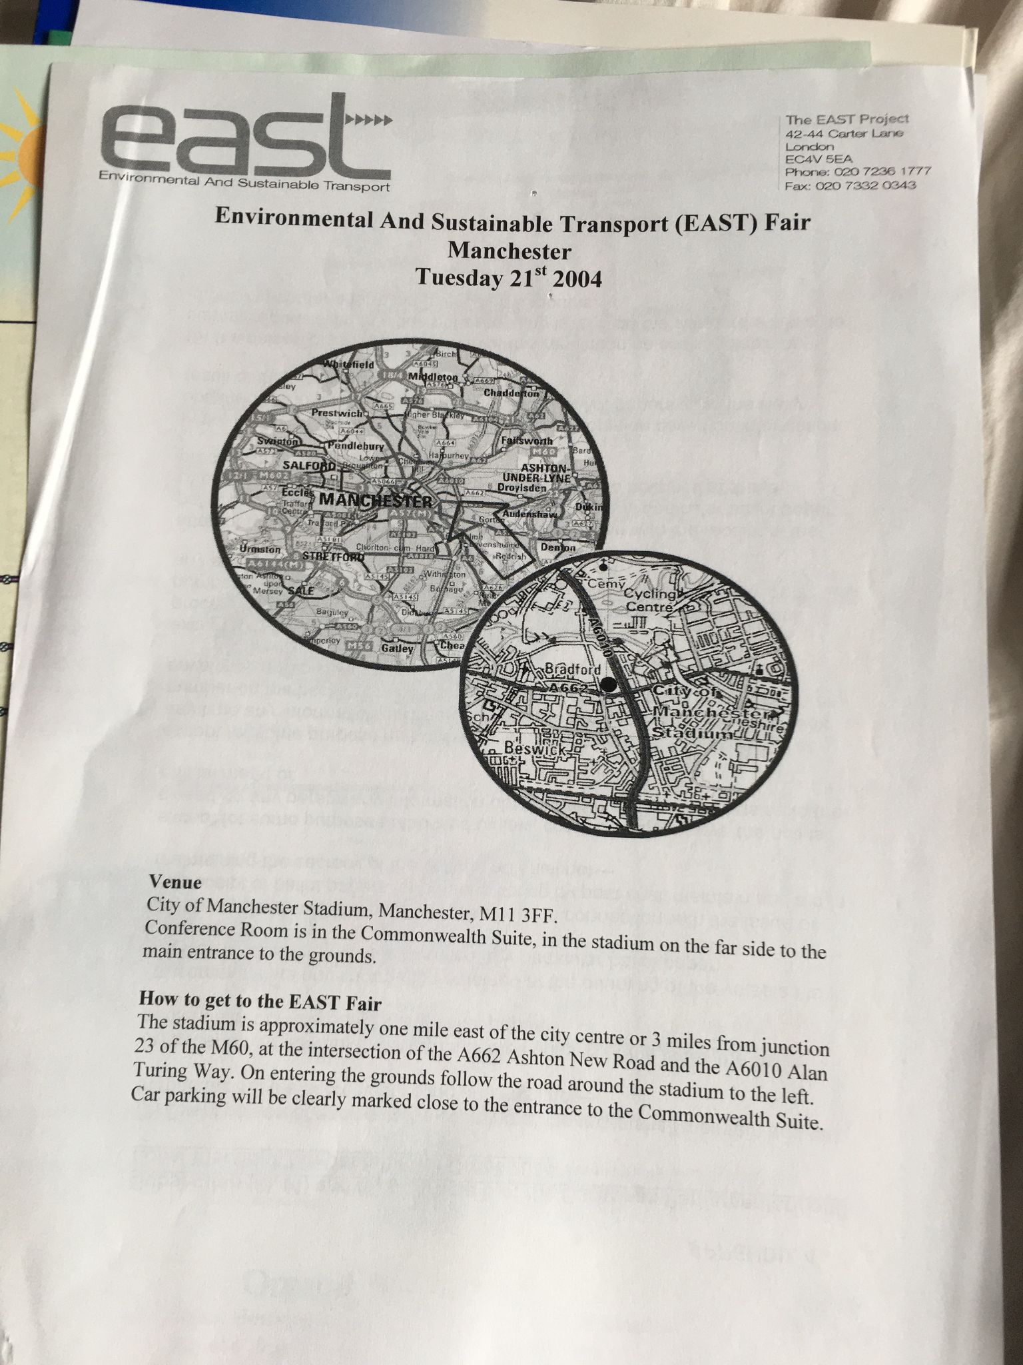

More cycling and walking

“Success” stories from other parts of the UK
Birmingham City Council has used emergency measures and funding during the COVID pandemic to make walking and cycling safer as well as help people maintain social distancing. This has been through:
- Delivering 5 out of 7 corridor “pop-up cycle lanes” routes identified within their Walking and cycling strategy and infrastructure plan
- Low traffic neighbourhoods and school street measures - pilots in Kings Heath, Lozells and two primary schools
- Widening pavements in local centres and suspending parking bays
- Cole Valley ‘green route’ for cycling & walking which includes improved green space and new cycle / pedestrian bridge.

Nottingham / Nottinghamshire
- Active Travel Funding - Tranche 1 - several small improvements (pop up cycle lanes, widening pedestrian walkways, dropped kerbs) - total allocated funding £263,250.
- Tranche 2 has £2.18m of funds, but not enough for £3m worth of proposed activities. Since Jan 2021 consultations have been running for Tranche 2 proposals. These include several segregated cycleways and footpath improvements along A-roads.

Glasgow
- Spaces for People Programme - delivered a series of temporary pedestrian and cycling travel spaces during COVID lockdown. May 2021 - consulting with the public on which of them to retain - https://www.glasgow.gov.uk/spacesforpeople. More details of temporary works here: https://www.glasgow.gov.uk/26008

- Nextbike hire scheme hit 1 million hires in June 2020. Launched in 2014, 79 hire sites across the city and 800 bikes. There were 500,000 hires in 2019, which shows the level of growth and increasing popularity of the scheme. In such schemes, social equity issues for other users of streets - pedestrians, wheel-chair users etc - must be considered, and the vulnerable (elderly, partially-sighted etc) must be protected.

Cornwall Council’s Community Network Panels:
19 community networks are the main way Cornwall Council connects with communities and helps address important local issues. These networks:
- Identify, agree and drive forward local priorities for their community network area
- Have their say on local service delivery and on strategies that affect their communities
- Work together to promote the wellbeing of their local areas and bring communities together
- Build relationships between the people and organisations working in their communities
The community networks have an annual £1m budget for transport / highway improvements - that’s about £50,000 for each network annually. See here for an example list of projects implemented / planned for Truro.

What could be done in Manchester?
Pop-up cycle lanes along arterial routes into the city centre were previously dismissed by MCC early in the pandemic. This decision should be reviewed by the Environment & Climate Change Scrutiny Committee, especially in light of encouraging more economic activity / footfall into the city centre without causing significant negative impacts on air quality by increased traffic. NO2 levels are breaching legal limits once again in Piccadilly - see this Twitter feed for evidence.

What needs to be done NOW, by who, to get the ball rolling
The Department for Transport (DfT) has given local authorities in England new powers to use CCTV to issue penalty charge notices to drivers who park or load illegally in mandatory cycle lanes, putting cyclists at risk of a serious accident.

Under Part 6 of the Traffic Management Act 2004, local authorities should have powers to enforce moving traffic violations, however this part of the Act was never activated through secondary legislation so only applies in London. The DfT has indicated that it might be in a position to enact this part of the legislation in mid-2021. MCC Highways should enquire immediately with DfT about this legislation and, if it is enacted, they should put together an enforcement plan for MCC traffic wardens. If not, they should push for this legislation to be brought forward.

More journeys on public transport

“Success” stories from other parts of the UK
Reading, Nottingham and Edinburgh, retained ownership of their municipal bus companies following deregulation. These services are still obliged to compete with private operators, but local authorities are able to reinvest their profits. For example, in 2019 Lothian Buses paid a dividend of £7.7 million to its shareholding councils. Northern Ireland also has publicly owned transport infrastructure in its rail and bus network.

Cambridge City Council is using licensing requirements to gradually upgrade the taxi and Private Hire Vehicle (PHV) fleet and manage a switch towards Electric Vehicles(EVs). New licenses are only issued to vehicles under four years old and meeting Euro 5 standard or higher. From April 2020 the Council only issues licenses to zero or ultra-low emission vehicles. Licenses will not be renewed on vehicles that are over nine years old or do not meet Euro 4 standard or higher. By 2028 the authority will only allow electric or ultra- low emission vehicles to be licensed. There is already a notable proportion of electric and hybrid taxis and PHV in central Cambridge.

What could be done in Manchester?
Greater Manchester is a pioneer when it comes to bus deregulation. Chris Boardman is the new transport commissioner, which is a legal role under The Transport Act 1985. He has the power to issue licences and ensure bus services comply with their licence conditions. Buses are legally bound to run services to timetables.

MCC could take a leadership role in lobbying GMCA to create a new municipal bus company with a shared ownership model where all GMCA boroughs invest. Rather than relying on private capital within this new bus company, a combination of GM Pension Fund and worker / community share ownership would be recommended to build a more democratically accountable and alternative business model to private franchises. This would eliminate the use of exploitative tactics such as fire and rehire to erode work pay and conditions as demonstrated by Go North West’s dispute at the Queens Road Depot, Cheetham Hill. This bus company would align with the region’s cooperative values and rich heritage starting small with a few popular routes within GM to build organisational capacity, skills and knowledge before rapid future growth.

Its values should centre on becoming an anchor organisation of community wealth, by employing local people with living wages and good benefits close to GMCA-owned depots to minimise additional commuting by car. This type of business model provides far more co-benefits and social value than private franchises as well as more sustainable revenue streams compared to the no-longer reliable carbon-intensive Manchester Airport dividend.

What needs to be done NOW, by who, to get the ball rolling
A debate at the Environment and Climate Change Scrutiny Committee on joint municipal / community ownership of a bus company within Greater Manchester with recommendations to be taken to GMCA and followed up at further scrutiny committees.

Fewer private car and truck journeys

“Success” stories from other parts of the UK
Birmingham City Council:
- An emergency ‘park, roll and stroll’ - two car parks where you can park up and cycle the remainder of your journey.
- Approached Business Improvement Districts (BIDs), hospitals, universities and local couriers to transition to e-cargo bikes with 20 being bid for and leased to organisations for 3 years with their partner the Active Wellbeing Society.
- An electric scooter trial for the city centre with docking locations close to public transport interchanges.
- A clean Air Zone came into force from 1st June 2021 for commercial vehicles & taxis.

Leeds City Council:
- Park & ride facilities Elland Road, Temple Green, Apperley Bridge and Kirkstall Forge designed to reduce city centre congestion and car reliance.
- Cycle superhighway between East Leeds and Bradford (protected & segregated cycle lanes)
- BBC 5Live have a year-long project tracking the city’s attempts to become carbon neutral by 2030

Royal Borough of Kensington and Chelsea:
- The council is moving from a resident parking permit structure with seven price bands to one which is more directly related to the CO2 emissions of the vehicle. This type of pricing for residents’ parking permits would be a first for the UK. The new charges come into effect 1 April 2021 and every resident living on a public road will be within 200 metres of an electric vehicle charging point. In this way, the parking offered by the borough would become fairer and greener.

The London Borough of Merton:
- Merton has aligned its car parking charges with public transport accessibility levels: there are higher charges for parking that has high levels of public transport accessibility, and lower fees for less well-served areas.

Nottingham
- A Workplace Parking Levy (WPL) was introduced into Nottingham in 2012. It is a charge payable by employers whose work premises have more than 10 employee parking spaces. The scheme has generated an additional £75m in revenue, which is ring fenced for local transport improvements. This has helped redevelop Nottingham Rail Station, improve the local municipally-owned ‘Link’ bus network and expand the NET tram network. A WPL has been twice previously rejected by MCC in 2018 and 2007 (with specific opposition from the Leader). A recent (Feb 2021) academic evaluation of the scheme showed that it constrained congestion growth without creating a disincentive to attract new businesses to the city.

Glasgow
- A Low Emissions Zone has been implemented as part of the Scottish National Government scheme.
  - Phase 1 since 31 Dec 2018 applied to local buses only.
  - Phase 2 planned for 1 June 2023 - will apply to all vehicles. Though not in place yet, there is lots of information on the council website with list of exemptions, guidance to whether your car will need to comply and links to Scottish Government financial assistance to comply. Residents living in Glasgow Low Emissions Zone (LEZ) have a further year to comply.
- Co-wheels Car Club: 2,000 members in Glasgow of a Pay as you go car hire scheme available to book in as little as 1 hour, 24/7. Funding to support Glasgow LEZ has replaced 8 vehicles in the city centre with fully electric alternatives. Installed dual sided EV charging equipment in 10 locations alongside Co-wheels Car club vehicles.
- Improved Traffic Signal Infrastructure: 2 junctions upgraded to run MOVA control, an adaptive traffic control system which reduces congestion and subsequently pollution. Work commenced in Jan 2020 and completed March 2020.

Planning guidance in London now sets the maximum amount of parking for new residential developments. These are determined by individual boroughs and are estimated to have reduced parking provision for new developments by 40%.

What could be done in Manchester?
A parking permit scheme with pricing linked to vehicle CO2 emissions and a high density of EV charging points could be designed to start in the city centre and then expanded from there on out.

Controlled parking zones created outside the city centre, in areas where transport accessibility levels are highest - those with links to tram lines, train stations and frequent bus services. Charges can again be linked to CO2 emissions of the vehicle to disincentivize multiple car ownership and of large SUVs / all-terrain trucks. Discounts / exemptions / EV grants provided for low income / disabled / other vulnerable users should be provided to those who still require the use of a car.

What needs to be done NOW, by who, to get the ball rolling
MCC Highways along with town planners could identify sites where Park and Ride provision could be provided with low cost / intervention, rather than creating new tarmac hard surface spaces. They could also repurpose existing work car park spaces that are not used during the weekend / evenings e.g. airport parking provision in South Manchester.

The dominance of the car needs to be challenged - this will lead to some level of conflict (what other way can you challenge dominance?) especially with the ‘motor lobby’ and taxi drivers. Manchester City Council must play its full part in demonstrating effective leadership to manage and de-escalate this conflict. If it fails to display skilful leadership, plans will be derailed again as they have been in the past over measures such as congestion charges and the delayed low emission zone. Whilst the concerns of drivers / business owners relating traffic to economic activity should be acknowledged, their claims should be checked against.

In light of the academic study showing the effectiveness of a workplace parking levy as well as Oxford, Leicester and Hounslow councils looking at implementing similar schemes. The Environment and Climate Scrutiny Committee should review the two previous decisions in 2018 and 2007 to reject similar schemes and whether something similar could be lobbied for at GMCA level with variable charges based on public transport accessibility.

The unheard herd of elephants in the room

The Airport
Since the COVID crisis struck Manchester City Council can no longer rely on it’s 35.5% stake in Manchester Airports Group (MAG) as a convenient source of commercial income (reported to be £70m in 2019-20), significant employer in South Manchester and central role in boosting the City’s economic growth.

Airports might have already been finding it increasingly difficult to turn a profit in pre-COVID times according to Peter Forbes, transport economist due to having to offer large discounts to airlines and car parking becoming the most profitable source of revenue.

The Committee on Climate Change says the increase in passenger growth must be limited to 25% compared with 2018 levels, which is lower than some airports were projecting before COVID. There is currently a significant misalignment between the growth ambitions of industry groups such as “Sustainable Aviation” and what can be compatible with a net zero emissions pathway and a potential shift away from business travel since video calling has become so widespread. There is also to take into account that the technology for ‘jet zero’ is nowhere near at the scale or readiness required for intercontinental travel.

Conclusions and next steps
If glossy well-presented and graphically designed reports solved climate change, you wouldn’t be reading this - everything would have been sorted long ago. Glossy reports don’t do it. “Political will” and leadership is required to take risks in order to match the necessary response to put policies in place that will both decarbonise the city whilst also tackling the basket of social inequalities that still blight many areas in Manchester.

We need a Scrutiny Committee that spends two quality hours a month on the climate emergency backed up by many more hours from paid officers doing more work to integrate climate into their work portfolios and departmental remits so that climate action is built into day-to-day council decision making and service provision. We question the effectiveness of arms-length organisations in its ability to do this. .

We need councillors who are willing and able to get up to (high) speed on this.

Glossary

Accelerating Transitions | Academic jargon for “we need to get a waggle on”. We need to go faster and further on shifting from high-carbon to low (zero) carbon, because we have done nothing substantive about climate change over the last 30 years.
Analysis paralysis | Failing to take action because things are confusing and there is always another scoping study, another pilot study to be conducted, that will allow difficult decisions to be deferred. Kicking the can down the road by asking for “further research.”
Decarbonisation | Switching from dirty fuels which release carbon dioxide (oil, coal, gas) to low/zero carbon technologies
Multi-Level Perspective | An academic way of looking at the world in which there are “landscapes” - big picture factors, a “regime” (big actors who are seeking to maintain or increase their power and profit) and “niche actors” who experiment, either to save the world with their new technology, or get very very rich and become regime actors (think Google 25 years ago, or Facebook 20 years ago)
Policy Learning | According to Wikipedia, this is “the increased understanding that occurs when policymakers compare one set of policy problems to others within their own or in other jurisdictions.” CEM is trying to accelerate this, and so help with accelerating transitions, reducing analysis paralysis and speeding decarbonisation
Silver Bullet-ism | The comforting and false idea that there is one magic silver bullet that, once found and fired, will magically solve all our problems. See also “technophilia” (the unreasoning love of technology).
Strategic Niche Management | Helping niche actors (see Multi-Level Perspective) learn, collaborate and be able to compete with the big boys (and it’s usually boys) in the regime...
Super-wicked problems | Read the wicked problem definition first!  Some academics (Levin et al, 2012) define super wicked problems as having the following additional characteristics:  - Time is running out.  - There is no central authority.  - Those seeking to solve the problem are also causing it.  - Policies discount the future irrationally.
Targets and their seductions | We love a target. It gives us a sense of having already achieved something. It gives us an excuse to not do anything right away. It’s akin to “analysis paralysis.”
Wicked Problems | A wicked problem is a social or cultural problem that's difficult or impossible to solve—normally because of its complex and interconnected nature. Wicked problems lack clarity in both their aims and solutions, and are subject to real-world constraints which hinder risk-free attempts to find a solution.  https://www.interaction-design.org/literature/topics/wicked-problems

Appendix: Methodology
We analysed BEIS local authority subset CO2 emissions data (excluding large industrial emitters and major road networks) in order to identify top local authorities across the UK across a range of measures.

We used 2014-18 as the most recent data available. We arrived at a list of councils with the greatest reduction in tonnes of CO2 (rather than percentage reductions). We excluded London Boroughs for this particular research, due to the unique nature of London’s transport network and higher historic levels of funding. However, where policy examples were found, which look applicable to other cities outside London they were included.

In terms of tonnes CO2 reduced between 2014-2018 outside of London the following councils were the top 10 outside of Manchester City Council. It was noted in conversations with other councils / cities as part of this research that there does not appear to be a strong link between historic emissions reductions and leading policy implementation. It has been suggested that reductions may be more closely related to the other factors such as:
1. “decarbonisation of the electricity grid”: in layperson’s terms, coal-fire power stations have been shut down and replaced with gas or renewable energy (mainly offshore wind)
2. after-effects of the 2008 global financial crisis and the resultant central government policy of austerity.

Absolute emission reductions 2014-18 (k tonnes CO2) from local authorities excluding London Boroughs
1 | Birmingham | -698.5
2 | Belfast | -575.8
3 | Leeds | -541.9
4 | Sheffield | -540.0
5 | Glasgow City | -497.4
6 | Manchester | -455.6
7 | Cornwall | -379.1
8 | Dorset | -371.2
9 | Trafford | -358.1
10 | Cheshire West and Chester | -339.3
11 | Liverpool | -320.5

We supplemented this with desk research about what different councils on this list had done. This involved some initial contact with relevant actors in some of these areas. This research is, however, only a “first pass.” It does not claim to be comprehensive, or the final word on the possible learning from other areas in the UK.

References/Further Reading

Broekhoff, D., Webb, M., Gençsü, I., Picciariello, A. and Scott, A. (2021). Decarbonising electricity: how collaboration between national and city governments will accelerate the energy transition. Coalition for Urban Transitions.
https://www.sei.org/publications/decarbonising-electricity-national-and-city-governments/

Levin, Kelly; Cashore, Benjamin; Bernstein, Steven; Auld, Graeme (23 May 2012). "Overcoming the tragedy of super wicked problems: constraining our future selves to ameliorate global climate change". Policy Sciences. 45 (2): 123–152. doi:10.1007/s11077-012-9151-0

